Title: Stuchbery Farm, Latrobe Road, Yarrambat
Prepared by: Trethowan Architecture, identified by Samantha Westbrooke

Address: Plenty Gorge Parklands, Yarrambat
Name: Stuchbery Farm, Smugglers Gully | Survey Date: 2016
Place Type: Farm, dairy | Architect: Unknown
Grading: Significant | Builder: Unknown – likely owner / builder
Extent of Overlay: Refer diagram | Construction Date: c1920

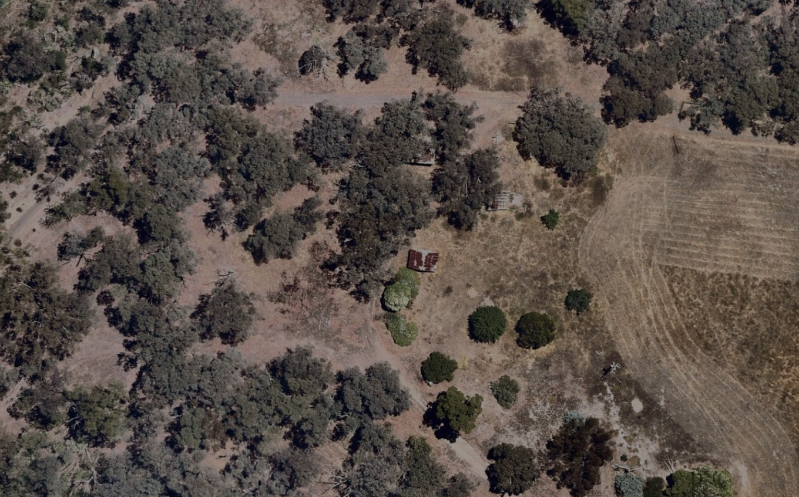
Aerial view showing the remnant farm structures within the parkland

Historical Context
Land to the west of Yan Yean Road, in the Parish of Marong, was sold at Crown land sales between 1840 and the early 1850s (Morang Parish Plan) The gold rushes brought an increase of population to the Diamond Valley and in their wake came the selectors who under the Selection or Land Acts of the 1860s, were able to purchase small holdings of land with the proviso that they improve them by clearing, fencing and building. Yarrambat, originally known as Tanck's Corner had a couple of gold rushes, one before 1860 and the other after 1900. However not enough gold was found to create a thriving township. The town was therefore primarily established by selectors. From the early 1860s commons were set up to allow settlers to graze livestock on Crown Land. The Greensborough Farmers’ Common was gazetted in 1861. The land in the common was described as “mostly Stringy Bark Forest & barren” (Greensborough Farmers’ Common File 907755, Item 21, Unit 892, VPRS242, PROV, Argus, 26 February 1861)

The lots on the north and south sides of Ironbark Road were the first to be taken by selectors Frederick Tanck and Thomas Reynolds in the early 1870s under sections 19 and 20 of the Land Act 1869, and they obtained their grants in the mid-1870s. Tancks Corner was a T-intersection where Ironbark Road meets Yan Yean Road. While the first land acts where mainly tailored to selection of blocks of viable farm size, gold miners and their associated service population lobbied for a system allowing small-holdings which would allow food gardens and keeping a horse and cow. Provision was soon made in the land acts for a system of occupation licenses for small areas of Crown land in auriferous areas. The resulting occupation licences on auriferous land, which were limited to twenty acres, were first introduced under Section 42 of the Land Act 1865. As gold was found in the area north of Nillumbik (Diamond Creek) relatively late, in the Tancks Corner locality twenty- acre occupation licenses were first taken up under Section 49 of the Land Act 1869. The first Section 49 licenses in the Tancks Corner area were taken up from c1883 (‘Greensborough County of Evelyn’, 1884).318 These were close to the eastern edge of the auriferous land, next to Tanck’s and Reynolds’ selections. Further licenses were progressively taken up under Section 65 of the Land Act 1884 over the whole of the auriferous area north of Nillumbik (Mills 2013).

While the occupation licenses did not at first allow for eventual alienation of the auriferous land, under political pressure allowances were made for purchase after a period of lease if it could be shown that mining was unlikely to occur in the future. The first alienations of twenty-acre lots near Tancks Corner occurred in the late 1880s, with alienation occurring gradually on the remaining twenty-acre lots into the 1920s (Mills 2013). This process of occupation also eventually led to the demise of the Greensborough Farmers Common, despite resistance by surrounding farmers (Argus, 14 March 1879:3). The Common was officially abolished in 1907 (Victoria Government Gazette, 10 July 1907, No.86 p.3330).

In the broad swathe of over 800 twenty-acre license holdings stretching from Nillumbik (Diamond Creek) to the north-east of St Andrews (Queenstown), the conjunction of these small lots and the hilly and relatively unfertile lands of the auriferous areas was a major stimulus to the establishment of the orcharding industry which was the mainstay of the area’s economy well into the twentieth century. A large proportion of the catchment population of the Tancks Creek/Yarrambat population made their living this way. The Tanck’s Corner school, which had opened in 1878 in response to the influx of selectors, closed in 1892, possibly because surrounding land was increasingly being bought for speculation (Butler 1996, p45; Hooper, 1978, p 8). The locals petitioned for reopening, at one stage listing forty-eight children within one-and-a-half miles of Tancks Corner (Hooper 1978:33). The reopening in c1900, along with the establishment of postal service and store around the turn of the century, was related to this new and intensive form of settlement.

Many of the people whose names became associated with Yarrambat did not settle there until the 1880s or 1890s. Henry Montague Pepper, with his wife and family, took up their selection in 1889. Thomas Collins, who had lived in Diamond Creek, moved with his wife to Yarrambat to start an orchard in 1886. Another early family, the Stuchbery's, did not select their land, but bought two acres of the Oatlands Estate in 1890. On the banks of the Plenty River, together with their twelve children, they established a market garden and built a house, dairy and stable. The name of the town was officially changed to Yarrambat in 1929. It is unknown why the name was changed however Yarrambat is named from an Aboriginal word meaning "high hills" or "pleasant views".

For a long period of time community life in the township centred on the school, which opened in 1878 on land donated by Thomas Reynolds. Although there was a blacksmith's shop and store at Yarrambat, the school was the only community building until the 1940s, when the fire station was built in 1947 (replaced in 2001) and the Yarrambat Hall in 1948. Parishioners of St Michaels, who met in the school, prior to having a dedicated church of their own, worked from the 1930s to clear land and build their Church. It was officially opened in 1954. The original school building has been moved to Yarrambat Heritage Park (located adjacent to Yarrambat Golf Course).

History

Portion 2 of Section 12 Parish of Morang was sold to Peter Davis at a Crown land sale in 1853 (Argus 1 April 1853:9). William Dunsford purchased part of the land in 1888 (CT: V1185 F973), and from c1893 leased part of it to the Stuchbery family who built a timber cottage with walls “of local stone and clay packed between boards until set” (Hooper 1978:70).

In 1920 a number of adjacent titles were amalgamated into one, and then re-subdivided (CT: V4282 F314). In 1923 Alfred Stuchbery purchased 124-acres including the land he had been leasing (CT: V4796 F039). Presumably this included the house and whatever other infrastructure the Stuchbery’s had created during the period of their lease.

The Stuchbery’s engaged in mixed farming and constructed a water wheel on the Plenty River to pump water up to a vegetable plot and the house (Hooper 1978, 70). Remnant farming structures evident on site include a dairy, well, part of a barn, well, elements of the garden, and evidence of the water race and pigsty (RNE Place ID 100394 ‘Stuchbery Farm Complex). The dates of these buildings and structures are not known.

Alfred Stuchbery died in 1934 And in 1935 the land went to Alfred’s wife Ada before it was acquired by their son Raymond and his wife Vida in 1938 (CT: V4282 F314). The land passed to Vida after Raymond’s death in 1958 (CT: V4282 F314). In 1974 she subdivided it into two lots separated by an extension of Latrobe Road, retaining the western portion containing the family’s remaining farm buildings (CT: V9045 F653 & CT: V9059 F654). The original farm building was demolished c1978 and replaced with a new dwelling (Hooper 1978a, p.70). Vida died 1980 and the land passed to her children (CT: V9059 F654).

Members of the Stuchbery family remained on the property until 1992/3 when the Melbourne Water Corporation acquired the land. In 1997 it was transferred to the Melbourne Parks and Waterways (CT: V9059 F654). The land is now part of the Plenty Gorge Park; the c1978 farmhouse that replaced the original has since been removed. A few non-native trees remain.

Description & Integrity

The following description relies on Samantha Westbrooke’s site visit and description prepared in 2016. Access difficulties prevented a follow up site visit in 2022.

The remnants of Stuchbery Farm lie within the Plenty Gorge Parklands managed by Parks Victoria. The farm complex is bound by Smugglers Gully to the north, Plenty River to the west, Latrobe Road to the east and Plenty Gorge Parklands to the south.

Stuchbery Farm consists of a complex of remnant farm buildings comprising stone and mortar dairy, two wells, stone and mortar sheds (remains of three), two stone slab floors of other buildings, remnants of cattle bails, a garage, remnants of a pig pen, a chook pen (cage) and garden cypress trees. On the river flat below farm is the site of an old shed and washing/boiling urn used in preparation of vegetables grown there. The construction of most of the buildings incorporated materials from the property.

The dairy is the most intact and well-preserved building on the site. It is constructed of stone and earth mortar, and rendered inside and out with earth and lime. It has a verandah back and front, a corrugated iron roof over a plank lining, timber door in the front and a small window in each of the front and back walls. Trunk saplings have been used for the corner supports. There is a paling fence at the front. Inside are two timber benches and timber blocks on the floor to hold down the milk churn. The ceiling has been removed. There is no evidence of any shelving.

The barn is of the same construction as the dairy with stones held in a matrix of earthen mortar. The exterior has not been rendered. Saplings form the timber supports. Only sections of the walls and roof framing remain. The floor is of flat boulders.

The well has been cut out of the bedrock. Where the walls are earthen, they have been lined with a rendering of earth and lime. The square well is adjacent to the barn and other sheds to which it supplied water.

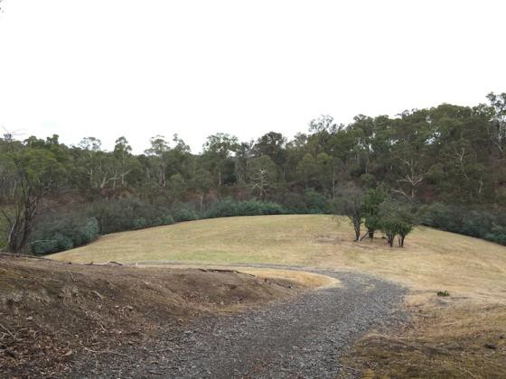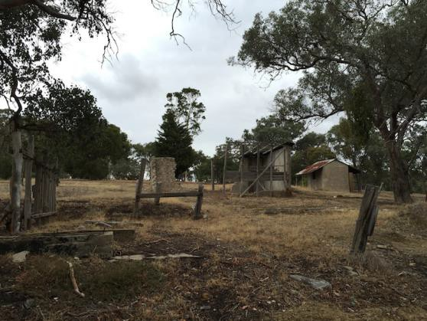

Figure 1. Former location of a farm shed on the river flats. Source: Samantha Westbrooke, 2016 | Figure 2. Remnant buildings at Stuchbery Farm. Source: Samantha Westbrooke, 2016

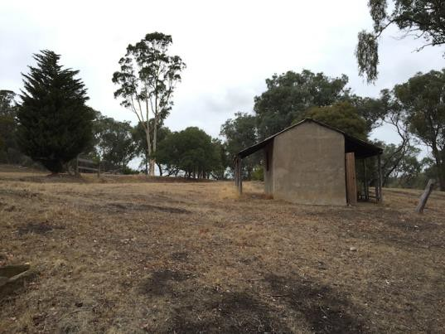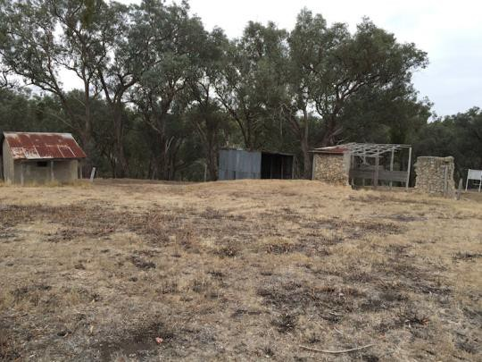

Figure 3. Dairy building. Source: Samantha Westbrooke, 2016 | Figure 4. Dairy, barn remains and corrugated iron clad garage. Source: Samantha Westbrooke, 2016

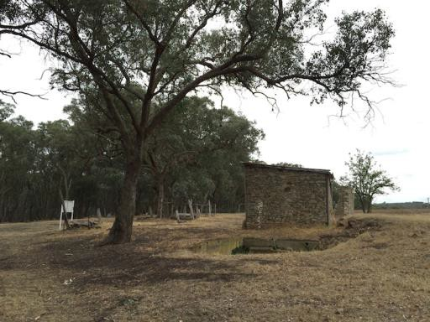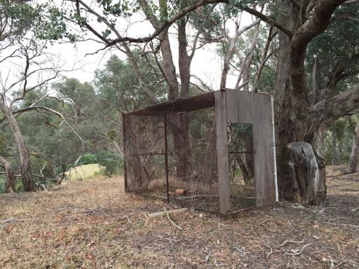

Figure 5. Barn remains and adjacent footings. Source: Samantha Westbrooke, 2016 | Figure 6. Chicken coup. Source: Samantha Westbrooke, 2016

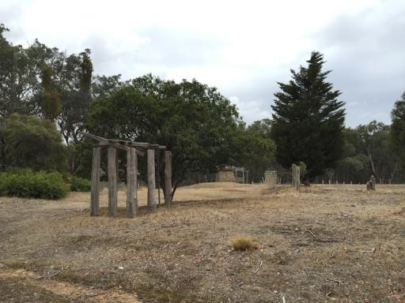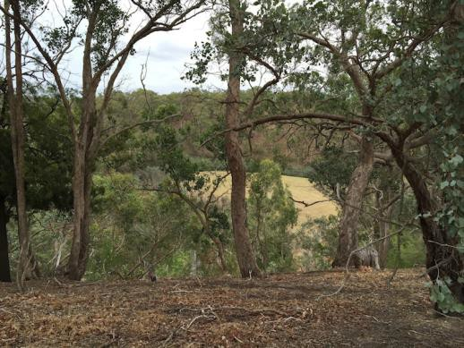

Figure 7. View to complex remains from east. Source: Samantha Westbrooke, 2016 | Figure 8. View to river flats from the farm complex. Source: Samantha Westbrooke, 2016

Comparative Analysis

There are limited relevant comparators to Stuchbery Farm currently on the Heritage Overlay in Nillumbik. HO267 (Batman Apple Tree and Pioneer Graves, 6A Hamish Court, Greensborough) is typologically comparable to Stuchbery Farm as a demonstration of riverbank settlement and mixed farming of the 1890s.

HO267 is limited to trees and a former cemetery site identified by plaques. Stuchbery Farm has much greater potential to yield information that will contribute to an understanding of the settlement and farming along the riverbanks in Nillumbik. Stuchbery Farm retains more remnants of the original property and evidence of varied land uses.

Stuchbery Farm, therefore, compares favourably against HO267 and is, in fact, a better examples of a former riverbank settlement from the late nineteenth-century.

There are four places in Yarrambat that are either currently listed or recommended for inclusion on the Heritage Overlay. These places are:

- HO219 St Michaels Church, 469-475 Ironbark Road
- House, Farm 52 Kurrak Road
- Farm Complex & Former Yarrambat State School, 651 Yan Yean Road
- Yarrambat General Store, 466 Ironbark Road

These places are not typologically comparable to Stuchbery Farm, and present different facets of the settlement of Yarrambat.

Assessment Against Criteria

Criteria referred to in Practice Note 1: Applying the Heritage Overlay, Department of Planning and Community Development, revised July 2015, modified for the local context.

CRITERION A: Importance to the course or pattern of the Shire of Nillumbik’s cultural or natural history (historical significance).

Stuchbery Farm is historically significant for its demonstration of mixed farming by farmers of little means, typical of the area and important to the development of Nillumbik. The scale of the property in the area and the form of tenure through leasing is atypical for the Nillumbik Shire. (Criterion A)

CRITERION B: Possession of uncommon, rare or endangered aspects of the Shire of Nillumbik’s cultural or natural history (rarity).

CRITERION C: Potential to yield information that will contribute to an understanding of the Shire of Nillumbik’s cultural or natural history (research potential).

Stuchbery Farm has research potential for its ability to yield information about the key components and layout of an early riverbank settlement and mixed farming. The remnant buildings and in particular the dairy demonstrate vernacular building style and techniques and the use of local materials for construction. (Criterion C)

CRITERION D: Importance in demonstrating the principal characteristics of a class of cultural or natural places or environments (representativeness).

CRITERION E: Importance in exhibiting particular aesthetic characteristics (aesthetic significance).

CRITERION F: Importance in demonstrating a high degree of creative or technical achievement at a particular period (technical significance).

CRITERION G: Strong or special association with a particular community or cultural group for social, cultural or spiritual reasons. This includes the significance of a place to Indigenous peoples as part of their continuing and developing cultural traditions (social significance).

CRITERION H: Special association with the life or works of a person, or group of persons, of importance in the Shire of Nillumbik’s history (associative significance).

Grading and Recommendations

Recommended for inclusion in the schedule to the Heritage Overlay of the Nillumbik Planning Scheme.

Recommendations for the Schedule to the Heritage Overlay (Clause 43.01) in the Nillumbik Planning Scheme:

External Paint Controls  Is a permit required to paint an already painted surface? | No
Internal Alteration Controls  Is a permit required for internal alterations? | No
Tree Controls  Is a permit required to remove a tree? | No
Victorian Heritage Register  Is the place included on the Victorian Heritage Register? | No
Incorporated Plan  Does an Incorporated Plan apply to the site? | No
Outbuildings and fences exemptions  Are there outbuildings and fences which are not exempt from notice and review? | Yes
Prohibited uses may be permitted  Can a permit be granted to use the place for a use which would otherwise be prohibited? | Yes
Aboriginal Heritage Place  Is the place an Aboriginal heritage place which is subject to the requirements of the Aboriginal Heritage Act 2006? | No

Proposed Extent:

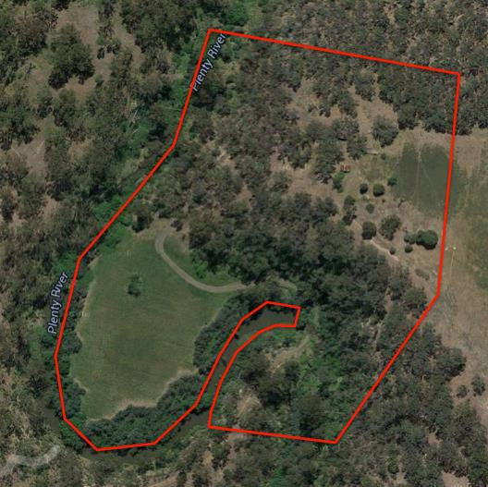

References

Advertiser (Hurstbridge), as cited.

Argus, as cited.

Edwards, Dianne H. 1979. The Diamond Valley Story: Shire of Diamond Valley.

Graeme Butler and Associates. 1996. Nillumbik Shire Heritage Review. Nillumbik: Nillumbik Shire.

Greensborough Riding of Heidelberg Shire Rate Books (RB), as cited.

Hooper, E 1978, Centenary Year: Tanck’s Corner, 1878-1978, Yarrambat.

Land Victoria, Certificates of Title (CT), as cited.

Peter Mills, "A History of Twenty-Acre Occupation Licenses on the Auriferous Lands of the Nillumbik Area," (Nillumbik Shire Council, 2013).

Register of the National Estate (RNE) Place ID 100394, ‘Stuchbery Farm Complex, 85-87 Latrobe Road, Yarrambat’, accessed online 12 November 2015.

