Title: Farm Complex & Former State School, 651 Yan Yean Road, Yarrambat
Prepared by: Trethowan Architecture

Address: 651 Yan Yean Road, Yarrambat
Name: Mayfields, River Glen | Survey Date: 2022
Place Type: Farm, house, outbuildings, school building, equipment | Architect: Unknown
Grading: Significant | Builder: Unknown
Extent of Overlay: Refer Diagram | Construction Date: 1856, 1920s, 1930s

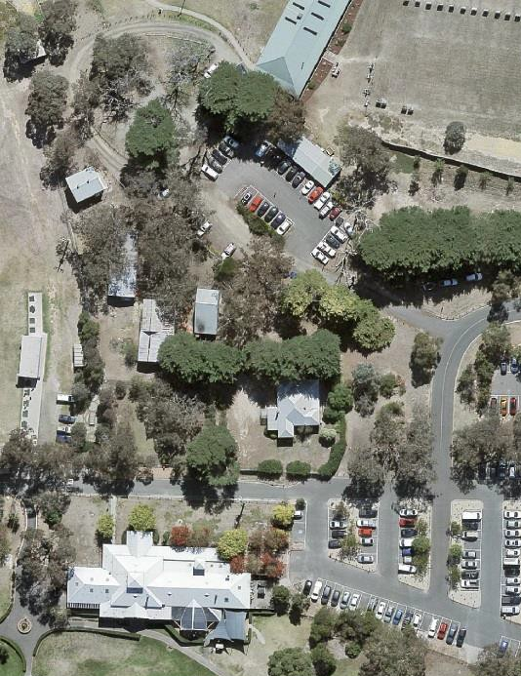
Farmhouse
Shearing Shed / Church
Iron sheds
School room
Figure 1: Aerial view of the site and complex of buildings.

Historical Context

Land to the west of Yan Yean Road, in the Parish of Marong, was sold at Crown land sales between 1840 and the early 1850s (Morang Parish Plan) The gold rushes brought an increase of population to the Diamond Valley and in their wake came the selectors who under the Selection or Land Acts of the 1860s, were able to purchase small holdings of land with the proviso that they improve them by clearing, fencing and building. Yarrambat, originally known as Tanck's Corner had a couple of gold rushes, one before 1860 and the other after 1900. However not enough gold was found to create a thriving township. The town was therefore primarily established by selectors. From the early 1860s commons were set up to allow settlers to graze livestock on Crown Land. The Greensborough Farmers’ Common was gazetted in 1861. The land in the common was described as “mostly Stringy Bark Forest & barren” (Greensborough Farmers’ Common File 907755, Item 21, Unit 892, VPRS242, PROV, Argus, 26 February 1861)

The lots on the north and south sides of Ironbark Road were the first to be taken by selectors Frederick Tanck and Thomas Reynolds in the early 1870s under sections 19 and 20 of the Land Act 1869, and they obtained their grants in the mid-1870s. Tancks Corner was a T-intersection where Ironbark Road meets Yan Yean Road. While the first land acts where mainly tailored to selection of blocks of viable farm size, gold miners and their associated service population lobbied for a system allowing small-holdings which would allow food gardens and keeping a horse and cow. Provision was soon made in the land acts for a system of occupation licenses for small areas of Crown land in auriferous areas. The resulting occupation licences on auriferous land, which were limited to twenty acres, were first introduced under Section 42 of the Land Act 1865. As gold was found in the area north of Nillumbik (Diamond Creek) relatively late, in the Tancks Corner locality twenty- acre occupation licenses were first taken up under Section 49 of the Land Act 1869. The first Section 49 licenses in the Tancks Corner area were taken up from c1883 (‘Greensborough County of Evelyn’, 1884).318 These were close to the eastern edge of the auriferous land, next to Tanck’s and Reynolds’ selections. Further licenses were progressively taken up under Section 65 of the Land Act 1884 over the whole of the auriferous area north of Nillumbik (Mills 2013).

While the occupation licenses did not at first allow for eventual alienation of the auriferous land, under political pressure allowances were made for purchase after a period of lease if it could be shown that mining was unlikely to occur in the future. The first alienations of twenty-acre lots near Tancks Corner occurred in the late 1880s, with alienation occurring gradually on the remaining twenty-acre lots into the 1920s (Mills 2013). This process of occupation also eventually led to the demise of the Greensborough Farmers Common, despite resistance by surrounding farmers (Argus, 14 March 1879:3). The Common was officially abolished in 1907 (Victoria Government Gazette, 10 July 1907, No.86 p.3330).

In the broad swathe of over 800 twenty-acre license holdings stretching from Nillumbik (Diamond Creek) to the north-east of St Andrews (Queenstown), the conjunction of these small lots and the hilly and relatively unfertile lands of the auriferous areas was a major stimulus to the establishment of the orcharding industry which was the mainstay of the area’s economy well into the twentieth century. A large proportion of the catchment population of the Tancks Creek/Yarrambat population made their living this way. The Tanck’s Corner school, which had opened in 1878 in response to the influx of selectors, closed in 1892, possibly because surrounding land was increasingly being bought for speculation (Butler 1996, p45; Hooper, 1978, p 8). The locals petitioned for reopening, at one stage listing forty-eight children within one-and-a-half miles of Tancks Corner (Hooper 1978:33). The reopening in c1900, along with the establishment of postal service and store around the turn of the century, was related to this new and intensive form of settlement.

Many of the people whose names became associated with Yarrambat did not settle there until the 1880s or 1890s. Henry Montague Pepper, with his wife and family, took up their selection in 1889. Thomas Collins, who had lived in Diamond Creek, moved with his wife to Yarrambat to start an orchard in 1886. Another early family, the Stuchbery's, did not select their land, but bought two acres of the Oatlands Estate in 1890. On the banks of the Plenty River, together with their twelve children, they established a market garden and built a house, dairy and stable. The name of the town was officially changed to Yarrambat in 1929. It is unknown why the name was changed however Yarrambat is named from an Aboriginal word meaning "high hills" or "pleasant views".

For a long period of time community life in the township centred on the school, which opened in 1878 on land donated by Thomas Reynolds. Although there was a blacksmith's shop and store at Yarrambat, the school was the only community building until the 1940s, when the fire station was built in 1947 (replaced in 2001) and the Yarrambat Hall in 1948. Parishioners of St Michaels, who met in the school, prior to having a dedicated church of their own, worked from the 1930s to clear land and build their Church. It was officially opened in 1954. The original school building has been moved to Yarrambat Heritage Park (located adjacent to Yarrambat Golf Course).

History

Sales of land in the Parish of Morang were held in April 1840. Portion 13 Parish of Morang 555 acres was purchased by Robert Fleming. Portion 13 was subdivided into large lots that began to sell in 1898. Leslie Woodbourne Clarke of the nearby Doreen property ‘Linton Grange’ purchased a 217-acre lot in the centre of this land in 1918 (CT: V2547 F295).

William Mayfield purchased the land from Clarke in 1928 (CT: V4126 F026). Other sources indicate, however, that E. Lynch and family had lived on the property prior to this sale (Argus 3 September 1928: 19 and Advertiser (Hurstbridge) 10 August 1928: 2). Topographic maps of 1920 and 1930 show that a house was built, in the position of the current building, during the 1920s. (Cth Dept. of Defence 1920, and Australian Section, Imperial General Staff. c1930). In 1934 the Cunningham family were leasing the property for dairy farming (Advertiser (Hurstbridge) 12 June 1936: 1). It was described as: “one of the largest, if not the largest acreages of the [Yarrambat] district properties” (Advertiser (Hurstbridge) 20 April 1934: 1).

By 1936 Frederick Leonard Young and family occupied the property. (Advertiser (Hurstbridge) 14 August 1936: 4). The name of the farm may have been changed at this point as there is newspaper reference to F. Young of ‘River Glen’ Yarrambat in 1938 (Advertiser (Hurstbridge) 8 July 1938: 2). The Young’s may have had a lease at first, as titles indicate that the 217-acre lot was transferred to Frederick Young, farmer of Doreen, 1942 (CT: V4126 F024).

Frederick Snr died in 1951, and the land went to his son Len Young (CT: V4126 F024 and Age 2 June 1951: 11). Len bought the adjacent 100-acre lot to the south in 1949 (CT: V3914 F731). Another 55 acres to the north was purchased from Mr J. Jeffery (Len Young, 1998).

The Shire of Diamond Valley purchased the parcels of land in 1981 (CT: V4126 F024 and CT: V3914 F731).

Len Young recounts that the family lived at first in a “mud” house for a few years while the land was cleared. This may have been the house built by the Lynches in the 1920s. Len Young later built the existing weatherboard house (Len Young, 1998).

Relocated Buildings
There are two buildings relocated to this site – a former Church used as a shearing shed, and a former school room.

The shearing shed is a converted 150-year-old former Wesleyan Methodist Church. The structure was first erected as a church at Separation, west of Mernda, in 1856. The hall was purchased at auction in 1939, dismantled and moved to the Young’s farm and re-erected as a shearing shed (Len Young, 1998). The shearing shed was restored in 2005-6 (YHS, 2015).

The Tanck’s Corner School No.2054 opened on land donated by selector Thomas Reynolds in May 1878, in response to the wave of selection in the area following the Land Acts. The current Yarrambat Primary School still stands on this land at 552 Yan Yean Road. Butler states that it was remodelled in 1920 and moved to a new site nearby (Graeme Butler and Associates 1996, p.45). The differences between early photographs (probably pre 1920s) and later photographs (c1950s), such as roof pitch and plan, may indicate that a completely new schoolroom with shallow pitched was provided at this point (Blake 1973). In 2002, the Yarrambat Heritage Museum moved the Yarrambat Primary School classroom to this site (YHS 2005).

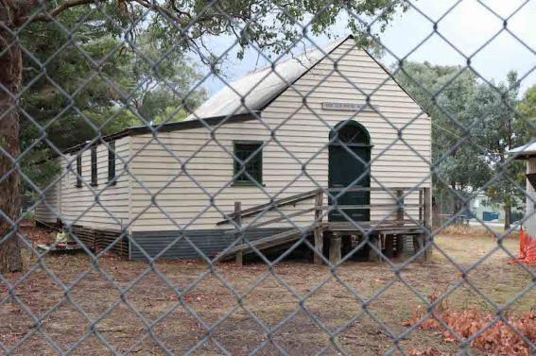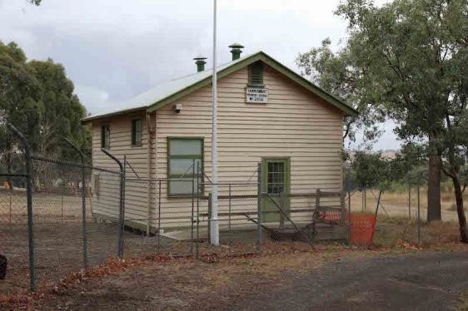
Figure 2: Former church / shearing shed (left) and former school room (right) relocated to this site. Source: Samantha Westbrooke, 2016.

Description & Integrity
The site is located in the north-east corner of the Yarrambat Golf Course. Formerly the Young farm, it retains the 1930s farmhouse, shearing shed (which is a converted church) and two other corrugated iron clad outbuildings, as well as the relocated school room (Figure 1).

Farmhouse
The farmhouse is a weatherboard building with a square floor plan and a main hipped roof with hip roofed projecting bays to the front (east) and to one side (south). The projecting wing to the front has a semi-circular bay window. The verandah runs along the east and south sides terminating at the projecting wings. The building is substantially intact. The original windows are box tripartite timber framed typical of a late 1930s – 1940s residence.

There is a row of pines in front of the residence and a palm tree at the south east corner.

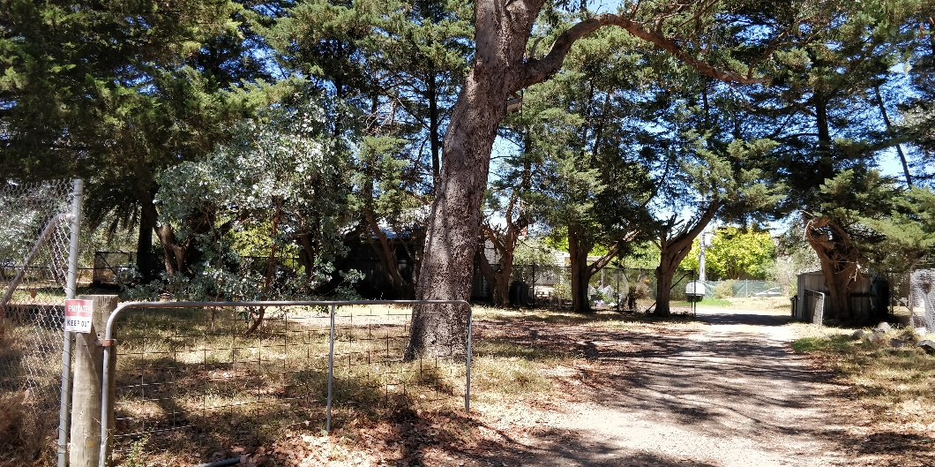
Figure 3: View of the weatherboard house behind mature garden. Source: Trethowan Architecture, 2022.

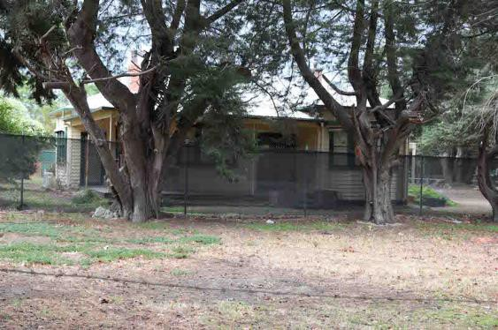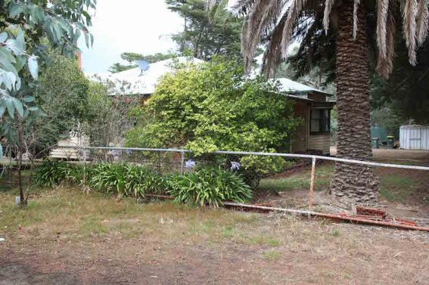
Figure 4: Front (left) and side (right) views of the farmhouse. Source: Samantha Westbrooke, 2016.

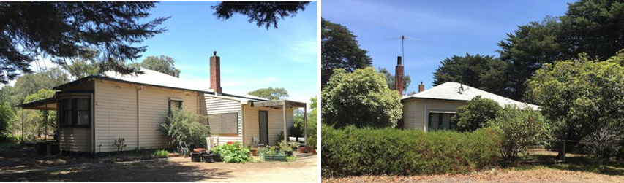
Figure 5: North (left) and south (right) elevations of the house. Source: Samantha Westbrooke, 2016.

Farm buildings – shearing shed & outbuildings
The shearing shed is constructed of weatherboard and consists of a gable roofed nave/hall and a skillion addition to one side presumably added as part of its conversion to a shearing shed. There is a central arched door to the front gable end indicating the former use of the building as a church.

There are corrugated iron clad, steel framed sheds either side of the shearing shed.

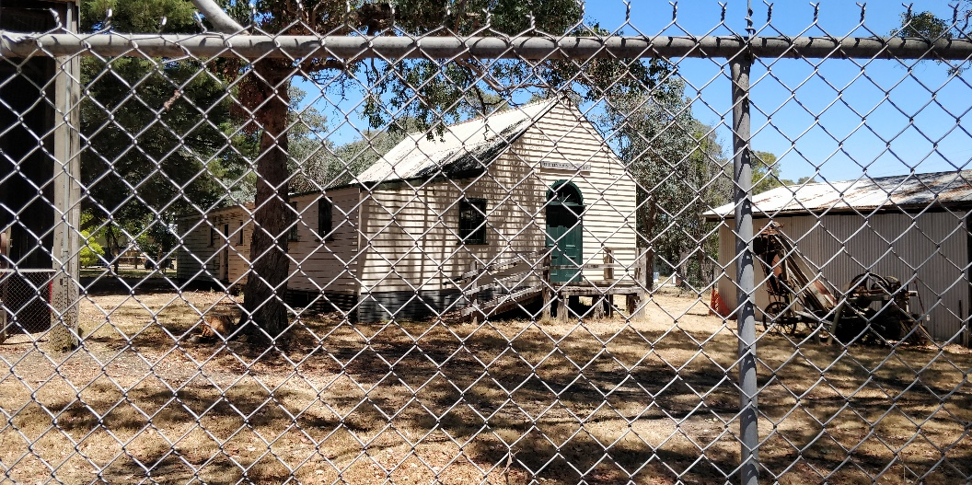
Figure 6: View of the shearing shed. Source: Trethowan Architecture 2022.

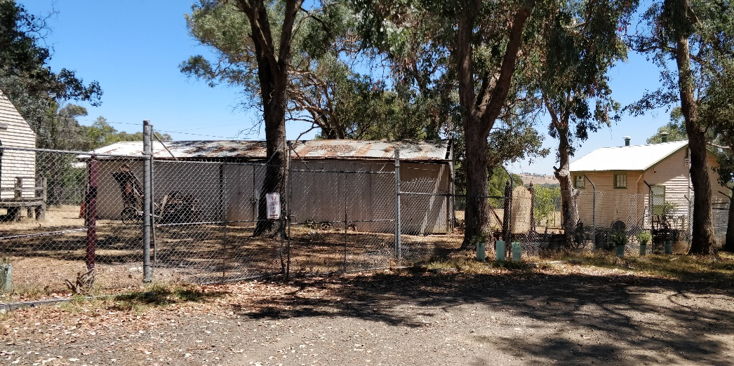
Figure 7: View of an outbuilding / machinery shed. Source: Trethowan Architecture, 2022.

Figure 8: View of farm machinery adjacent to iron shed.

Former school room
The former Yarrambat Primary School classroom is a single-roomed weatherboard building with a near square footprint. It has a low-pitched gable roof clad in corrugated iron. There is a door and small window to the front elevation, two windows to the east elevation and it appears that a window has been removed from the west elevation.

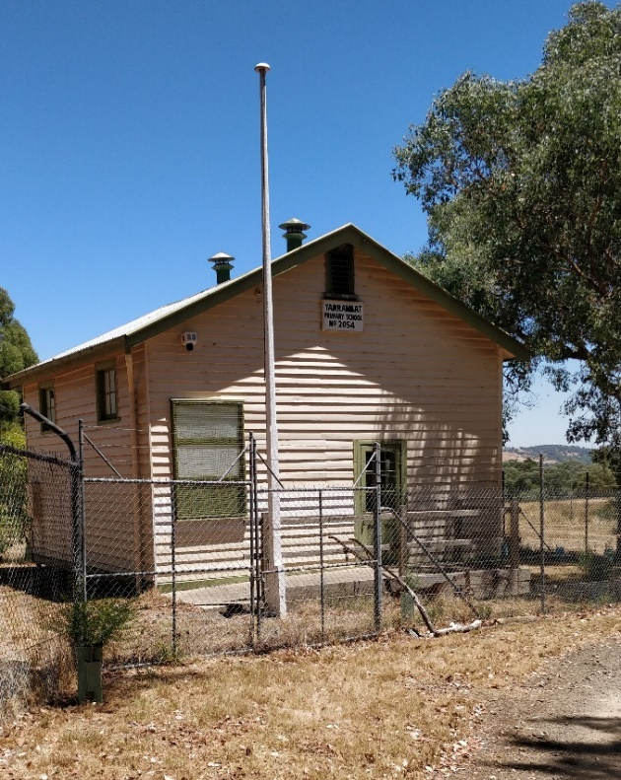
Figure 9: View of the schoolroom. Source: Trethowan Architecture, 2022. | Figure 10: Side elevation of the school room. Source: Samantha Westbrooke, 2016.

Comparative Analysis

651 Yan Yean Road is an example of an interwar farm complex retaining the 1920s farmhouse and corrugated iron outbuildings, as well as the repurposed former Church used as a shearing shed. The relocated school room does not relate to the former farming use but contributes to the character of the place.

The former farming complex at can be compared with other interwar farm complexes (comprising house and outbuildings), and with other shearing sheds. Interwar farming properties are underrepresented in the Heritage Overlay (HLCD 2009).

The former school room can be compared with other late nineteenth-century school buildings already included on the Heritage Overlay. Relocation of school buildings was a common practice in the late nineteenth and early twentieth centuries based on need (Butler 2001). The school room at 651 Yan Yean Road, therefore, can also be compared with other examples of relocated school buildings.

Farmhouses
Weatherboard farmhouse & outbuildings, 760 Hurstbridge-Arthurs Creek Road, Arthurs Creek (HO89) includes a c1905 weatherboard farmhouse and outbuildings dating pre-1920. The site is associated with the MacMillan family of orchardists and demonstrates the areas former fruit growing industry. The farm complex at 651 Yan Yean Road is a later example and is related to dairy farming rather than the prominent orcharding industry, or the interwar pattern of mixed farming on smaller lots. Nevertheless, both properties represent the changing farming practices that were seen in the early twentieth century. Both properties are constructed of timber, which was an economical and readily available building material.

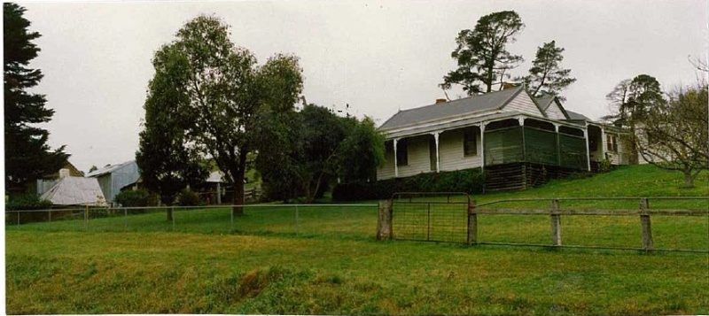
Figure 11: MacMillan Farm. Source: Shire of Eltham Heritage Study, 1992.

860 Cottles Bridge-Strathewan Road, Arthurs Creek (HO28) is an orcharding property that incorporates a c1913 weatherboard house as well as a 1920s/1930s house. The later house demonstrates the transition to the bungalow style incorporating nested front gables, shingles to the gable ends, low roof pitch and timber detailing. The house at 651 Yan Yean Road is similar as a 1930s weatherboard dwelling, however it does not take on the emerging bungalow style seen at Cottles Bridge-Strathewan Road. The house at 651 Yan Yean Road demonstrates the conservative character and delayed adoption of stylistic trends.

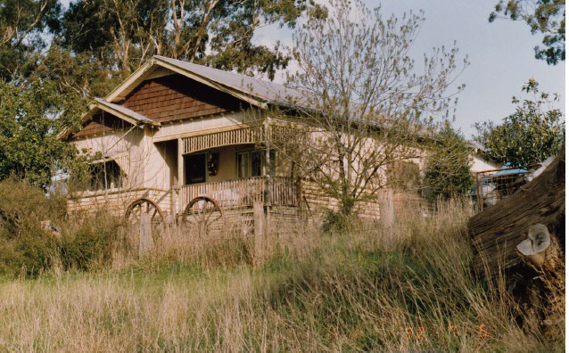
Figure 12: View of the 1920s/1930s weatherboard bungalow at 80 Cottles Bridge-Strathewan Road. Source: Shire of Eltham Heritage Study, 1992.

14-26 Browns Lane, Plenty (c1924) is covered by interim Overlay HO270. It is a representative example of an interwar bungalow, originally part of a mixed farming property including orcharding and poultry. Both properties are representative of agricultural development in the interwar period, and are stylistically conservative. The house at 651 Yan Yean Road is later, but is stylistically similar to the Browns Lane house, eschewing the emergent Californian Bungalow style that had become dominant in suburban Melbourne.

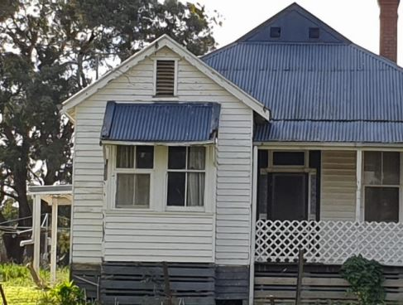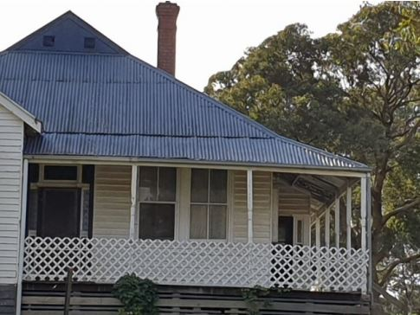
Figure 13: Façade of house at 14-26 Browns Lane, Plenty. Note the weatherboard construction. Source: Citation for 14-26 Browns Lane, plenty prepared by Context 2021.

Outbuildings
Heffernan farm outbuildings, at 104 Thomson Crescent, Research (HO247) are a series of farm outbuildings including a corrugated iron clad gabled shed / workshop from the interwar period. Together the buildings demonstrate the areas pre-1950s economy which was principally agricultural.

The farm complex at 651 Yan Yean Road is comparable as a complex of farm buildings that demonstrate the district’s former dominant industry. Both sites are surviving examples of vernacular, utilitarian construction.

School buildings
Christmas Hills Primary School 1362 at 1409 Eltham-Yarra Glen Road, Christmas Hills (HO53) is an example of a c1880 weatherboard school building. Both this building and the former school room at 651 Yan Yean Road are constructed of timber and are modest buildings with simple detailing. However, the Christmas Hills school is at a larger scale on an L-shaped plan incorporating a teacher’s residence. The Christmas Hills school remains in its original location and forms part of the current Primary School. This continuity of use and location distinguishes the Christmas Hills school as a more significant example of its type in Nillumbik.

Diamond Creek State School SSI003 at 85 Cowin Street, Diamond Creek (HO31) is a timber school building dating from c1870. The Diamond Creek school is a larger and more complex building demonstrating a later development in education compared with the single square school room at 651 Yan Yean Road. Nevertheless, both buildings demonstrate early local education in regional communities, and modest timber construction.

Primary (state) school 2105 and former residence at 275 Eltham-Yarra Glen Road, Kangaroo Ground (HO47) is a cluster of school buildings including a simple timber school room c1887. Both this school room and the one at 651 Yan Yean Road are constructed of timber and take simple orthogonal plans with gable roofs. Both buildings retain good levels of intactness and demonstrate early local education facilities in small communities.

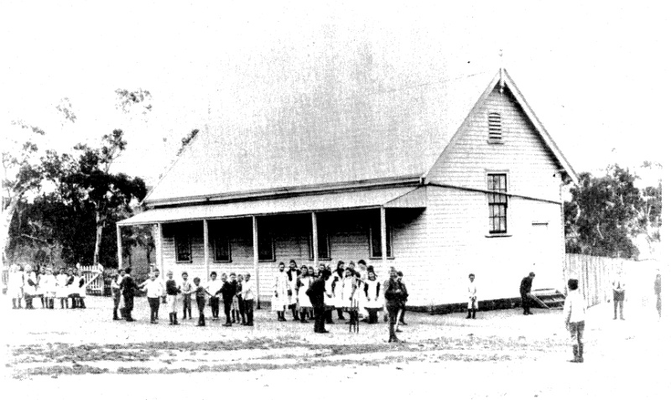
Figure 14: Historic image of the Kangaroo Ground school room. Source: Shire of Eltham Heritage Study, 1992.

Scout’s Building – previously State School No 3939 buildings, at 20 Anzac Avenue, Hurstbridge (HO3) includes the 1886 former Gobur State School which was moved to the site in 1947. The former school building is a modest, rectangular, weatherboard building with a gable roof and simple detailing. It compares favourably with the former school room at 651 Yan Yean Road, as an example of an early school building relocated according to need.
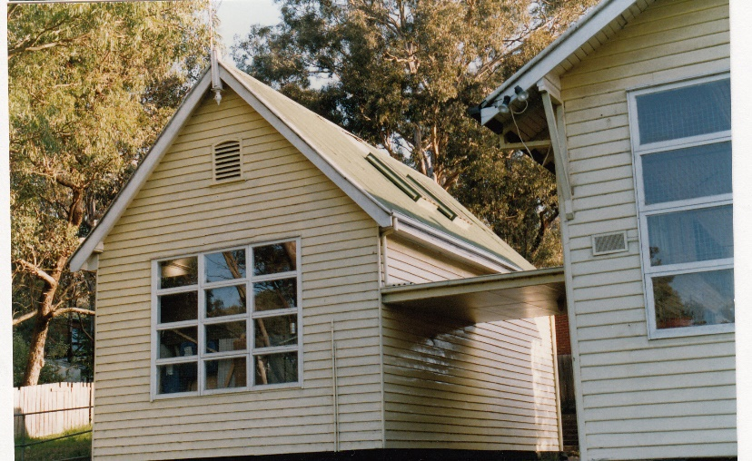
Figure 15: Former State School 3939. Source: Shire of Eltham Heritage Study, 1992.

St Andrews State School No 128 Building, 35 Caledonia Street, St Andrews (HO20) includes an 1887 school building and part of the relocated 1876 Smith’s Gully school. This is a modest, simply-detailed weatherboard school building of the late nineteenth century. Both this building, and the school room at 651 Yan Yean Road demonstrate the common practice of relocating school buildings. Both buildings are modest, timber structures with gable roofs demonstrating the simple, vernacular construction of the period.

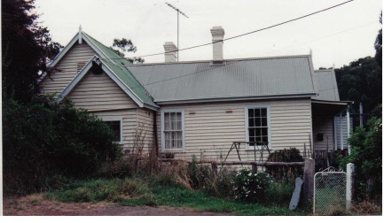
Figure 16: St Andrews School. Source: Shire of Eltham Heritage Study, 1992.

The former farm complex at 651 Yan Yean Road demonstrates developing farming practices from the interwar period, as the district diversified away from the dominant orcharding industry. The house and outbuildings demonstrate the former use of the land, supported by the relocated timber church that became a shearing shed. It compares favourably against other examples of interwar farm complexes already included on the Heritage Overlay.

The school room does not relate to the former farming activities or the main period of development of the place. It does, however, demonstrate early educational development in regional areas and the common practice of relocating school buildings in the late nineteenth and early twentieth centuries. It compares favourably with other nineteenth-century timber school buildings, often remodelled and / or relocated to meet changing community requirements.

Assessment Against Criteria

Criteria referred to in Practice Note 1: Applying the Heritage Overlay, Department of Planning and Community Development, revised July 2015, modified for the local context.

CRITERION A: Importance to the course or pattern of the Shire of Nillumbik’s cultural or natural history (historical significance).
The farm complex and former state school at 651 Yan Yean Road is of historical significance as the former River Glen property, which was unusually large into the interwar period, and for the scale of the farming operation.
It is historically significant for the two timber buildings relocated to this site. The shearing shed is a former Methodist Church dating from the 1850s. The school room dates from 1878 and was remodelled / relocated in the 1920s. It was again relocated to this site from the current Yarrambat Primary School site. This demonstrates the common practice of relocating school buildings according to need.

CRITERION B: Possession of uncommon, rare or endangered aspects of the Shire of Nillumbik’s cultural or natural history (rarity).
N/A

CRITERION C: Potential to yield information that will contribute to an understanding of the Shire of Nillumbik’s cultural or natural history (research potential).
N/A

CRITERION D: Importance in demonstrating the principal characteristics of a class of cultural or natural places or environments (representativeness).
The farm complex and former state school at 651 Yan Yean Road is of aesthetic significance for the substantially intact 1930s farmhouse, 1920s school building and 1856 church converted to a shearing shed. Each of the three main buildings retain many original details and their original purpose and appearance are easily legible.
The complex of buildings incorporates corrugated iron clad sheds, farm machinery and mature trees.

CRITERION E: Importance in exhibiting particular aesthetic characteristics (aesthetic significance).

CRITERION F: Importance in demonstrating a high degree of creative or technical achievement at a particular period (technical significance).
N/A

CRITERION G: Strong or special association with a particular community or cultural group for social, cultural or spiritual reasons. This includes the significance of a place to Indigenous peoples as part of their continuing and developing cultural traditions (social significance).
N/A

CRITERION H: Special association with the life or works of a person, or group of persons, of importance in the Shire of Nillumbik’s history (associative significance).
N/A

Grading and Recommendations

Recommended for inclusion in the schedule to the Heritage Overlay of the Nillumbik Planning Scheme.

Recommendations for the Schedule to the Heritage Overlay (Clause 43.01) in the Nillumbik Planning Scheme:

External Paint Controls  Is a permit required to paint an already painted surface? | Yes
Internal Alteration Controls  Is a permit required for internal alterations? | No
Tree Controls  Is a permit required to remove a tree? | Yes – mature pines and palm tree around house
Victorian Heritage Register  Is the place included on the Victorian Heritage Register? | No
Incorporated Plan  Does an Incorporated Plan apply to the site? | No
Outbuildings and fences exemptions  Are there outbuildings and fences which are not exempt from notice and review? | No
Prohibited uses may be permitted  Can a permit be granted to use the place for a use which would otherwise be prohibited? | Yes
Aboriginal Heritage Place  Is the place an Aboriginal heritage place which is subject to the requirements of the Aboriginal Heritage Act 2006? | No

Recommended Extent
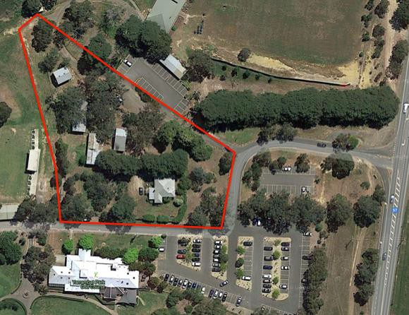

Identified by Samantha Westbrooke

References

Advertiser (Hurstbridge), as cited.

Age, as cited.

Argus, as cited.

Blake, L.J., ed. 1973. Vision and Realisation: a centenary history of state education in Victoria
Vol. 3. Melbourne: Education Dept. of Victoria.

Butler, Graeme and Associates. 1996-2001. Nillumbik Shire Heritage Review. Nillumbik: Nillumbik Shire.

Edwards, Dianne H. 1979. The Diamond Valley Story: Shire of Diamond Valley.

HLCD Pty Ltd, 2009, ‘Shire of Nillumbik Heritage Gap Study Framework – a framework for the assessment of places of potential significance in the Shire of Nillumbik’ prepared for Nillumbik Shire Council.

Hooper, Eileen. 1978. Centenary Year: Tanck's Corner 1878-1978, Yarrambat 1878-1978. Yarrambat: Yarrambat State School

Land Victoria, Certificates of Title (CT), as cited

Morang Parish Plan. The Colonist (Sydney), 25 April 1840 p3

Victoria, Yan Yean [cartographic material], Australia 1:63,360 topo series, Commonwealth Dept. of Defence Melbourne, Govt. Printer 1920, SLV Map Collection.

Victoria, Yan Yean [cartographic material] / prepared by Australian Section, Imperial General Staff. Great Britain. War Office. General Staff. Australian Section, c1930, 1:63,360 topo series. SLV map collection.

Yarrambat Historical Society (YHS) Website, http://yarrambathistoricalsociety.org.au/about- us/4590002084 accessed 8 December 2015.

Young, Len. 1998, ‘The Len Young Woolshed’ interpretation board on site

