Communications Strategy
2022-2025

This document is available in Easy English format. Easy English conveys key messages using simplified concepts and a specialised library of images. It is particularly beneficial for people with low English literacy, people with intellectual disability and people who speak English as a second language.
If you need the Communications Strategy 2022-2025 in another format, please contact Nillumbik Shire Council on 9433 3111 or email nillumbik@nillumbik.vic.gov.au

If you are deaf or have a hearing or speech impairment,
please contact us through the National Relay Service on 13 36 77.

Acknowledgements
Nillumbik Shire Council respectfully acknowledges the Wurundjeri Woi-wurrung people as the Traditional Owners of the Country on which Nillumbik is located, and we value the significance of the Wurundjeri people’s history as essential to the unique character of the Shire. We pay tribute to all First Nations People living in Nillumbik, give respect to Elders past, present and future, and extend that respect to all First Nations People.
We respect the enduring strength of the Wurundjeri Woi-wurrung and acknowledge the ongoing impacts of past trauma and injustices from European invasion, massacres and genocide committed against First Nations People. We acknowledge that sovereignty was never ceded.
Wurundjeri Woi-wurrung people hold a deep and ongoing connection to this place. We value the distinctive place of our First Nations People in both Nillumbik and Australia’s identity; from their cultural heritage and care of the land and waterways, to their ongoing contributions in many fields including academia, agriculture, art, economics, law, sport and politics.
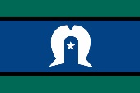
Nillumbik Shire Council is committed to creating a fair, equitable and inclusive community where human rights are respected, participation is facilitated, barriers are addressed and diversity is celebrated. We support the rights of all people regardless of age, gender, ability or background. We value the diverse and changing nature of our community and understand that some groups and individuals experience more barriers than others.

Contents
Acknowledgements 2
Message from the Council 4
Why do we need a whole-of-council Communications Strategy? 5
Strategy at a glance 6
Who is this Strategy for? 7
A snapshot of our diverse Nillumbik community 7
Our audience 8
Guiding principles 9
Challenges and focus areas 10
1. Reaching a broad audience 10
2. Engaging people’s interest 11
3. High volumes of information out and low volumes of insight 11
Outcomes 12
1. Increase numbers of ‘disengaged’ into ‘potentially engaged’ 12
2. Increase the relevance of our communication 12
3. Expand the reach of our communication 12
Our strategic objective 14
Strategic pillars of action 14
Trust and Transparency 15
Identity 16
Capability 17
Reach 18
Strategic alignment with the Community Vision – Nillumbik 2040
and the Council Plan 2021-2025 19
Implementation and reporting 20
Appendix 21
Appendix One: Action Plan 21
Appendix Two - How we currently communicate 30
Appendix Three - What we heard 32
Appendix Four - Text alternatives 34

Message from the Council
The Nillumbik Shire Council Communications Strategy 2022-2025, continues our commitment to place our community at the centre of everything we do.
This Strategy provides a robust framework to guide Council in its central aim of keeping our community connected to, and informed about, our programs, services and decisions in ways that are relevant and wide-reaching.
Importantly, it aims to foster and improve the two-way dialogue between Council and our community. What we’re told by our community is absolutely critical to our decision-making and service delivery.
Therefore we believe it appropriate that our Communications Strategy be informed by community feedback – obtained in consultation on a range of Council projects, our Annual Community Surveys and from consultation on the Strategy itself.
The Strategy recognises our community’s diversity and intersectionality, whether it be interests, cultural background, life stage, gender or the whole range of demographic markers.
It also recognises that people have different preferences in how – and how regularly – they wish to communicate with Council.
Its broad framework therefore lays the foundation from which to implement the communications methods to address the spectrum of views and needs in our community.
The Strategy is also available in different formats to make it as accessible, equitable and inclusive as possible. This was a recurring and strong sentiment in feedback received during our community consultation.
We would like to thank all who took the time to provide feedback and input as we developed the Strategy, which will be an important part of our toolkit as we continue to refine the ongoing conversation with our community, for even better outcomes over the coming years.
Image: Cr Peter Perkins, Cr Natalie Duffy, Deputy Mayor Cr Ben Ramcharan, Mayor Cr Frances Eyre, Cr Karen Egan, Cr Richard Stockman, and Cr Geoff Paine (2022) (left to right)

Why do we need a whole-of-council Communications Strategy?
Good communication is at the heart of everything we do.
The services we provide and the decisions we make affect the lives of people in our communities every day. Putting in place timely, effective and engaging methods of communicating with the community about services and programs, events and initiatives in the Shire, promotes equitable access to the things they need to feel connected and supported
In line with the actions of the Council Plan 2021-2025, this Strategy is our framework to deliver effective communication that continues to meet the needs of community members as they seek to be informed and engaged with Council and its activities.
This Strategy supports and is closely aligned to Council’s Community Engagement Policy, which outlines our commitment to engaging our community in planning and decision making. This Strategy outlines the ways we intend to reach, inform and connect with our community, as part of a two-way interaction, often in support of engaging with them on decisions that affect their lives.
It also supports our strong focus on advocacy, as highlighted in our Advocacy Priorities 2022 document. Together, these documents support our commitment to delivering our Community Vision – Nillumbik 2040, which emphasises the importance of Council working to keep our community engaged and connected (Go to “Strategic alignment with the Community Vision – Nillumbik 2040 and the Council Plan 2021-2025” page).
In line with our Access, Equity and Inclusion Policy, our communications activities within this Strategy help to drive equity, diversity and accessibility to information and enable broader community involvement in Council activities. It will also link closely with our Customer First Strategy as we continue to develop and refine the next iteration and that guiding document.

Strategy at a glance
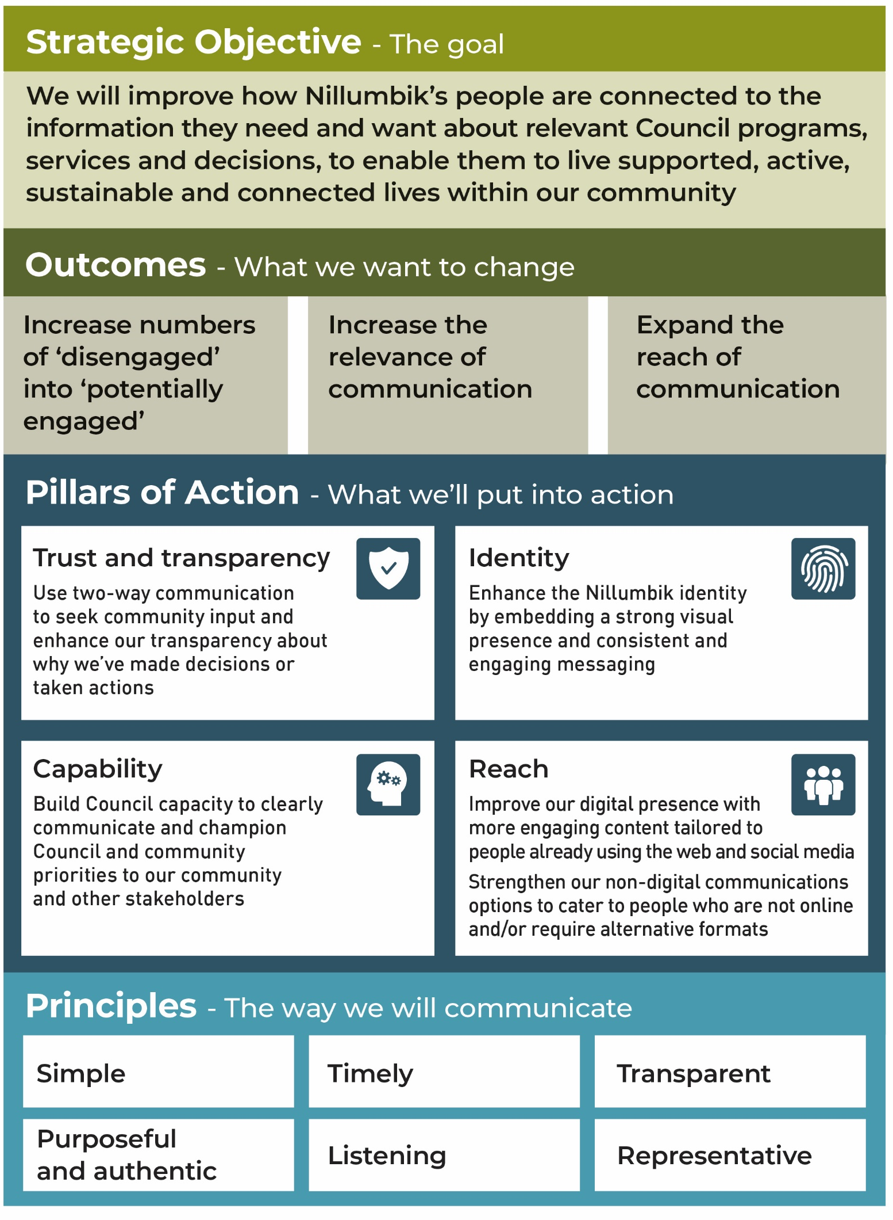Text alternative for “Strategy at a glance” infographic chart.

Who is this Strategy for?

A snapshot of our diverse Nillumbik community
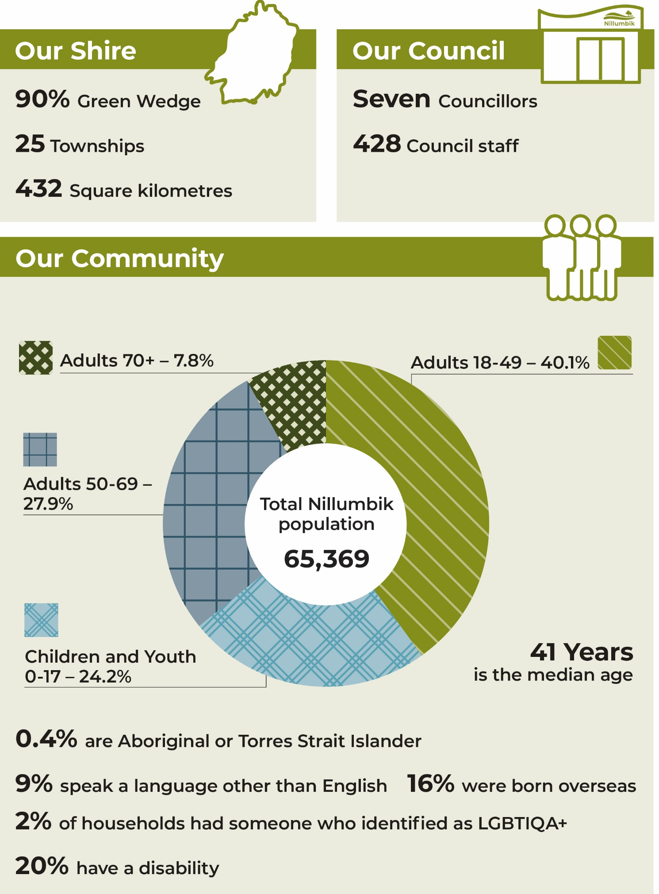
Text alternative for “A snapshot of our diverse Nillumbik community” infographic.

Our audience
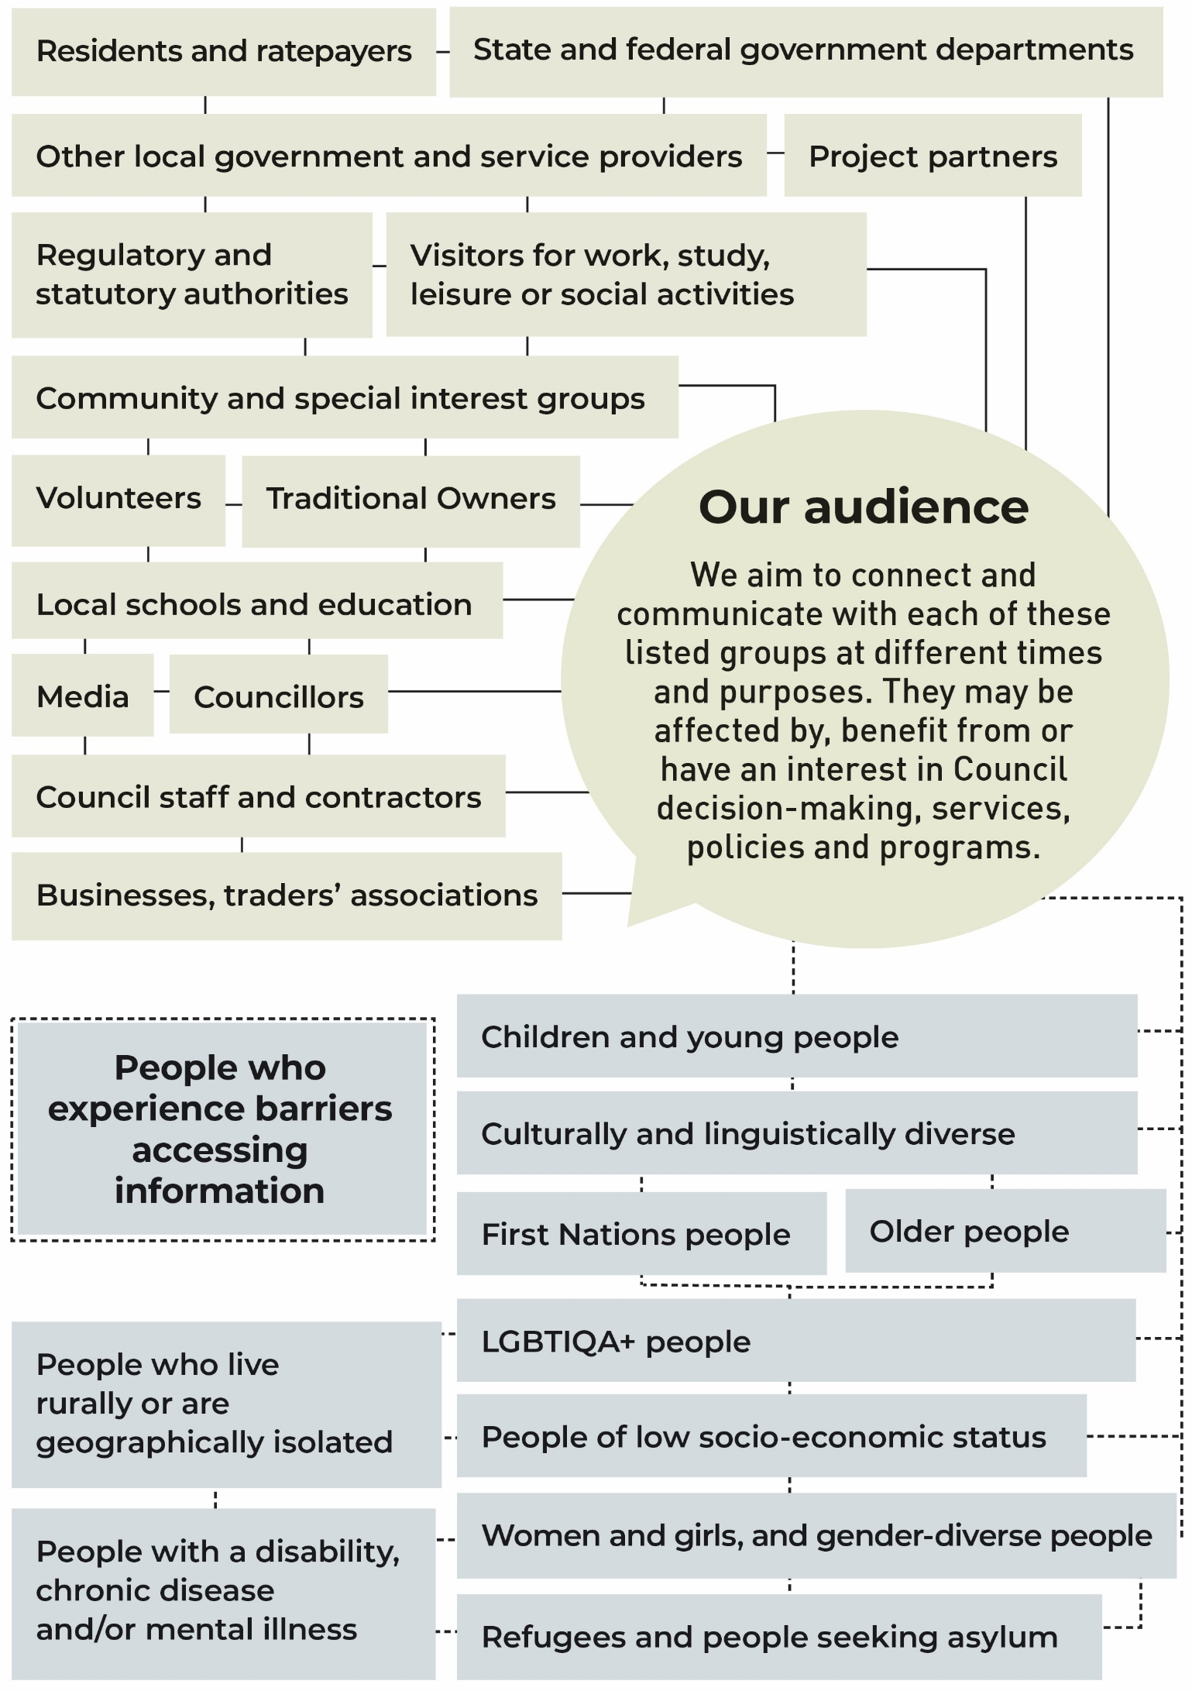
Text alternative for “Our audience” graphic.

Guiding principles
The following principles will guide the way we will communicate with our audiences to deliver honest and meaningful communications that meets their diverse needs.
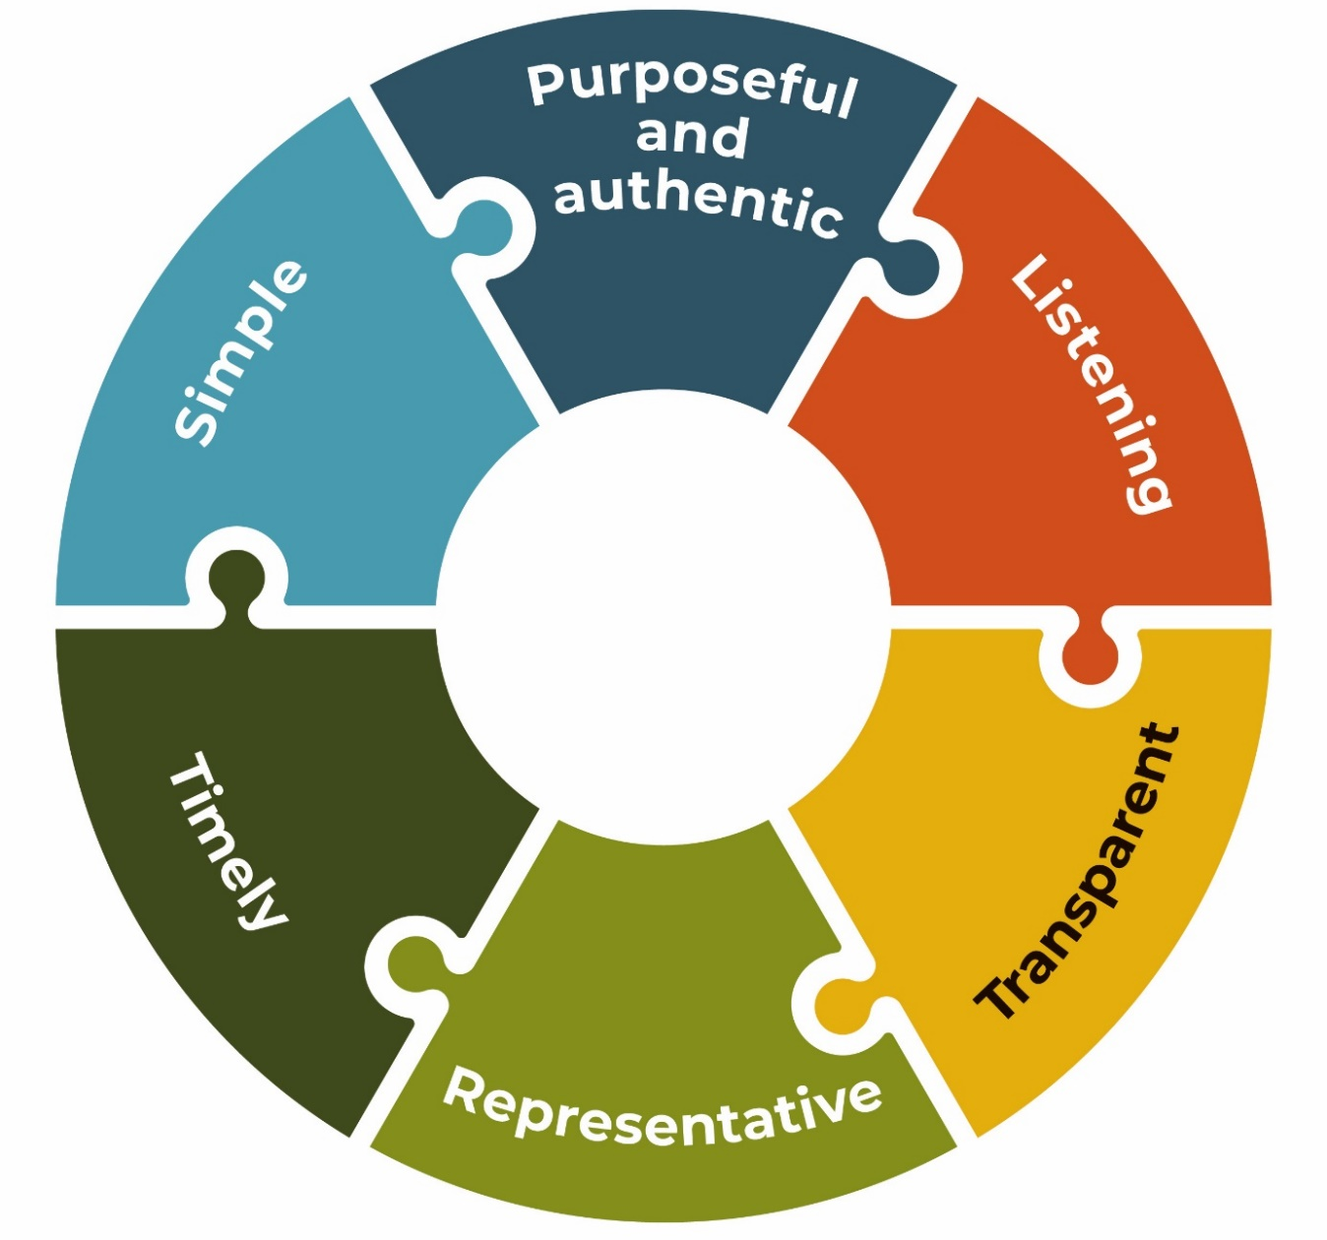

Simple - We use straightforward, easy-to-understand language that is accessible and adaptive.
Purposeful and authentic - Our communication is useful to our audience, is values-based, and we are authentic in our delivery.
Listening - We will listen, fostering two-way communication, feedback and input.
Transparent – We are transparent in our approach to engagement and communication - we show how we have listened and acted.
Representative - We cater to, target and represent the diverse needs of our Shire, providing information that aims to remove physical, social and cultural barriers. We represent our diverse community in our promotional imagery.
Timely - We give our communities enough time to receive our messages and enough time to participate. We respond in good time.

Challenges and focus areas
When it comes to communicating and informing our community, there are three potential challenges that are characteristic of the Nillumbik experience.

1. Reaching a broad audience
In a Shire where there is a significant urban population, but significant rural land area, the ways we reach our communities must be diverse and must include a mix of digital, printed and in-person methods.
- Urban residents typically have adequate mobile and internet connection and high digital device usage among some user groups. However, some groups, such as older residents, may not be using digital methods and require more direct-to-home or ‘at-place’ methods.
- Rural residents (those living within the Green Wedge zones) comprise about 12,000 out of the Shire’s approximately 65,000 residents. Mobile phone and internet coverage is at times limited in these areas. Further, a number of properties, especially in rural parts of the Shire, have no formal letterbox.
We recognise that there may be additional challenges for some in our community to feeling included, accessing information, resources and opportunities. Intersecting identities include characteristics such as:

- ability
- age
- faith
- gender expression
- language
- location
- mental health
- nationality
- race
- sex and sexual orientation
- socio-economic status.

2. Engaging people’s interest
When we communicate with our communities, we acknowledge that not everyone, at all moments in time, will wish to engage with us.
Many residents within the Shire prefer to seek information when they need it, having minimal interaction with Council unless a problem occurs and they are seeking a solution or service.
This group of ‘the unengaged’, may shift into ‘potentially engaged’ where the communication is interesting to them or has the most relevance to their lives at that point in time.
Compared to the majority, a cohort of residents and community groups exist that are ‘highly engaged’ with Council activity and decision-making and have high information and engagement needs.
Our strategy aims to reflect the needs of both the engaged, unengaged and potentially engaged groups, noting that enhancing the relevance of information to people’s everyday lives will assist in keeping the unengaged connected to vital information that serves them.

3. High volumes of information out and low volumes of insight
Council has the responsibility for delivering many services that directly impact the lives of those in our community. We therefore have a great deal of information to share about our services, laws, policies, programs and decisions. Understanding what is most important to specific areas of our community and what information they seek will help better target our communication to what people need and want, and help manage this volume.
However, while our Annual Community Survey gives a good indication of the ways that people like to hear from Council (such as online or direct mail), and their top issues related to satisfaction with Council, we lack an evidence-based understanding of ‘what’ people like to hear about from us.

Outcomes
In developing this Strategy, we have acknowledged these key challenges can impact the effectiveness of our communication and engagement activities within the community. The focus of this Strategy will be on achieving these three outcomes:

1. Increase numbers of ‘disengaged’ into ‘potentially engaged’
We recognise that not every resident or group within Nillumbik will wish to engage with us every time. Of those who are currently disengaged with Council, our best efforts should be directed to shifting them into ‘potentially engaged’ by finding: the cross-over where people’s interest and need meets our message at the time.
This means exploring targeted ways to reach those who may be potentially engaged, and inclusive ways to target those who experience barriers to accessing information.
The opportunity to be connected to information should be easily accessible to all who need it, and our communication will be better targeted to sectors of the community. To find that cross-over of community need and our message, we, at Council, will adopt a more proactive way of forward-planning our communication activity.

2. Increase the relevance of our communication
Our communication with our community should always be timely, relevant and accessible to its needs, and not only to Council requirements. We will aim to put our community at the heart of our stories, our language and our communications content.
Relevance means that we show the importance of our message/service/offering to the everyday lives of our community members. This means that our message and content approach will be strengthened to focus more on the language of and interest or benefits to our community and feature more inclusive and diverse representations of Nillumbik people in our images and stories.
To get that right, we’ll enhance our understanding with a stronger evidence base about what our community needs and wants.

3. Expand the reach of our communication
Our current methods of communication remain an essential part of how we communicate with our community, so our focus will be to enhance these methods with more evidence about what makes them successful. Priority actions in this Strategy seek to continue to build a clear picture of what works best for our community and will be further detailed in our implementation planning.
As audiences online continue to grow, we will continue to enhance our digital communication methods, such as social media and our website, while also realising more ‘placed-based’ avenues of communication and tapping into other communication networks to help spread the word to audiences that are not online.

Our strategic objective

We will improve how Nillumbik’s people are connected to the information they need and want about relevant Council programs, services and decisions, to enable them to live supported, active, sustainable and connected lives within our community.

We will do this through two-way dialogue, by expanding the reach of our message and increasing the relevance of, timeliness and trust in our communication with community.
With our Strategy’s focus on increasing the connection to and relevance of our communication to our audiences, the way we deliver and design our communications for them requires Council to adapt our approaches internally.
This strategic approach of building relevance and increasing the proactivity of our information, will underpin all of our communication activity going forward.

Strategic pillars of action
These four pillars inform the action plan that will deliver our strategic aim of connecting people to information in a more relevant way that expands the opportunity to reach them.

Trust and Transparency
Use two-way communication to seek community input and enhance our transparency about why we’ve made decisions or taken actions.

Identity
Enhance the Nillumbik identity by embedding a strong visual presence and consistent and engaging messaging.

Capability
Build Council capacity to clearly communicate and champion Council and community priorities to our community and other stakeholders.

Reach
- Improve our digital presence with more engaging content tailored to people already using the web and social media.
  - And:
- Strengthen our non-digital communications options to cater to people who are not online and/or require alternative formats.

Trust and Transparency
Use two-way communication to seek community input and enhance our transparency about why we’ve made decisions or taken actions.

Key Actions
- Build relationships with third parties via an ‘open door’ to help inform the broader community about Council services and decisions, recognising their independence.
- Review regularly how the community wish to engage with us, what they want to hear about and what they’ve told us.
- Consistently show the action we’ve taken to listen, advocate for and respond to community issues.
We will focus on working better with third parties, such as interested community and civic groups, local and metropolitan media, and prominent local identities, to share Council information, news and decisions, with the full information we can provide them. We will show how we’ve listened and what we’ve heard, and how we have or why we couldn’t take on feedback in final decisions made. We will ensure that feedback, responses and our plans for further engagement occur in a timely way.

Identity
Enhance the Nillumbik identity by embedding a strong visual presence and consistent and engaging messaging.

Key Actions
- Refocus our messaging to be 'audience-centric' and feature a greater number of and more diverse representation of the people of our community.
- Create a forward plan of our content based on known interests of people at particular times of year.
- Build a clear evidence base of ‘what works’ and what information people seek from us through research and data analysis.
We will focus strongly on building relevance in our messages to our audience’s interest and their diverse needs, enhancing Council services as welcoming for everybody.
By engaging and consistent messaging, we mean:
- Simple, but not dull, language that is accessible and targeted. We use the appropriate tone for the message, but most importantly we speak authentically as a Council that cares for its community.
- Using angles of interest to the community in our messages, such as highlighting the benefits of a Council service to people’s social, economic, physical or mental wellbeing. Feature community enjoying or benefiting from a Council service or event.
By persistent visual presence we mean:
- Consistent use of the Nillumbik brand style on all digital and physical communication materials across Council.
- Allowing our creative, ‘green’ and community-focused identity to shine through diverse and representative imagery and graphics.

Capability
Build Council capacity to clearly communicate and champion Council and community priorities to our community and other stakeholders.

Key Actions
- Provide in-house training in how to use branding and content creation that is audience focused, not ‘Council focused’.
- Work together to build a forward plan for meaningful community engagement opportunities.
- Develop guidance and tools to assist all areas of Council to understand the diversity of audience needs and what is effective. Place inclusiveness, accessibility and equity in access at the core of communications messages and methods.
There are many points of contact between our community and Council. Across the organisation, knowledge varies about community needs and about how best to interact with our community. Consistency of message across Council to community can also vary. We will focus on how the Communications and Engagement team can assist others within Council create a consistent and streamlined experience
for community and stakeholders with how we better engage and communicate
with them.

Reach
- Improve our digital presence with more engaging content tailored to people already using the web and social media.
  - And
- Strengthen our non-digital communications options to cater to people who are not online and/or require alternative formats.

Key Actions
- Explore the feasibility of new physical communications methods to target ‘hard-to-reach’ community at places they frequent, such as noticeboards.
- Drive people to our online methods (social media, e-newsletter) through a campaign that highlights ‘What locals need to know’ and offer incentives to connect with Council.
- Keep people engaged with better digital content - more video, more inclusive and welcoming images and more about ‘them’.
- Repurpose content - good stories across e-newsletters and various sites get lost ‘forever’ and seen by only small audiences.
A number of our community members spend significant time online but don’t follow Council on our social media channels or request our e-newsletters. Engaging with Council doesn’t come to mind for these audiences, unless they get something ‘delivered’ to their letterbox, or have an issue to resolve. We will focus on creating more ‘digital impressions’ for those already online, by offering more engaging social media content that captures their attention. Council will implement a sustained campaign to entice community to include Nillumbik into their digital ‘feeds’ by subscribing or following us.
Recognising that a portion of our community isn’t online, may be harder to reach geographically or socially, or face barriers to accessing information, we will focus also on finding new physical spaces and network opportunities to promote key activities and opportunities.
Go to Appendix One – Action Plan to view the Priority Actions and Measures of Success under each pillar.

Strategic alignment with the Community Vision – Nillumbik 2040 and the Council Plan 2021-2025
The Strategy is a priority action of the Council Plan 2021-2025 and also aligns with other objectives and actions within the Plan. It supports and is closely aligned to Council’s Community Engagement Policy, our Access Equity and Inclusion Policy and our Advocacy Priorities for 2022. It will also align with future iterations of the Customer First Strategy. All four of these documents support our overall Community Vision - Nillumbik 2040.
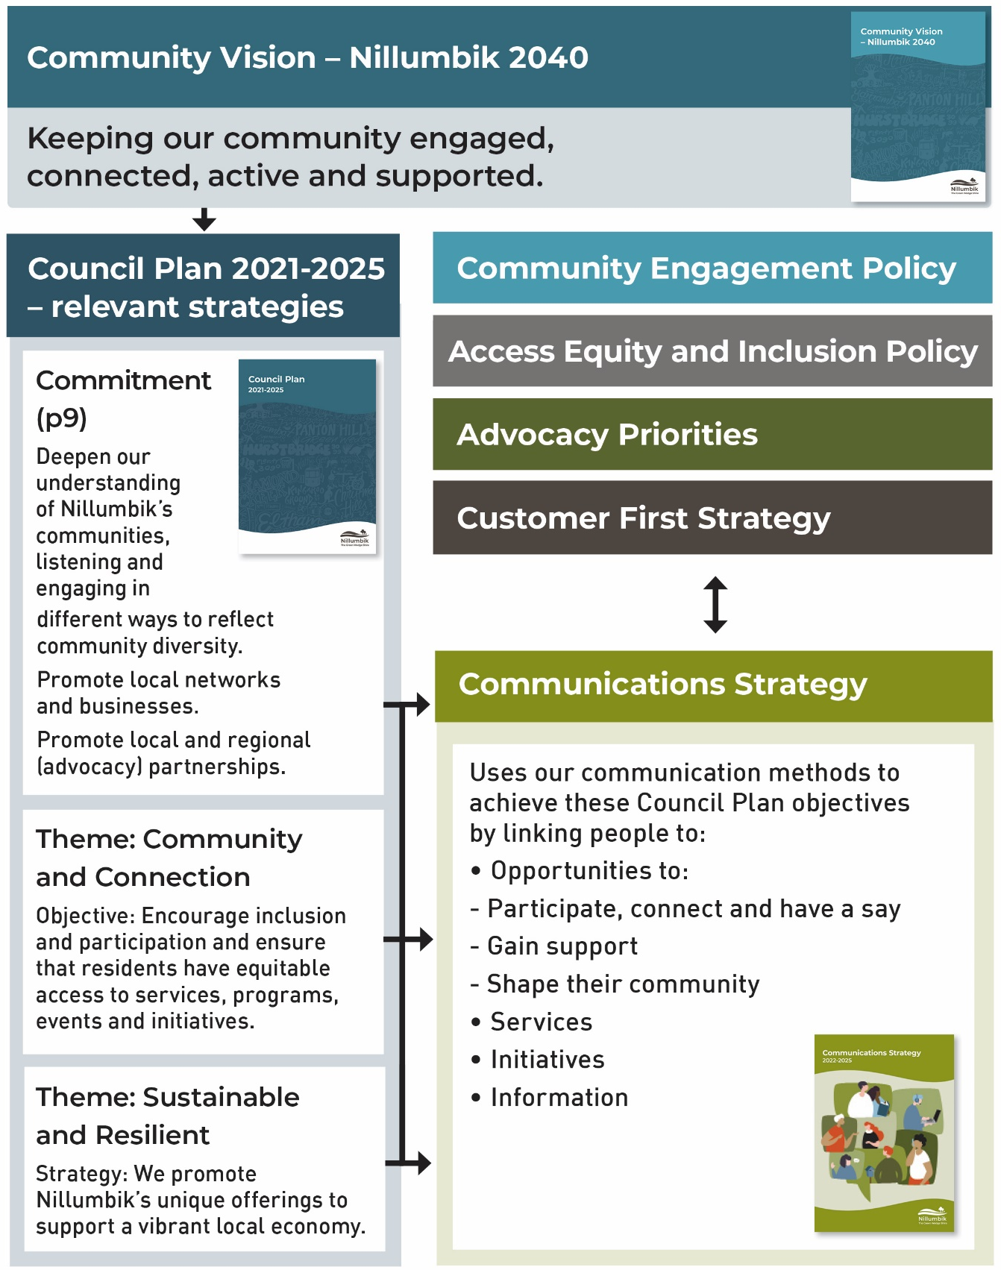
Text alternative for the “Strategic alignment” flowchart.

Implementation and reporting
Council is committed to monitoring and reporting progress on the actions in our Communications Strategy.

Implementation
In line with the timeframes for the Council Plan, this Strategy guides our actions to end of 2025.
Our Strategy’s Priority Actions will be reviewed every year and updated where necessary to reflect current needs or changes. We will also indicate where actions are complete or ongoing.
An internal Annual Action Plan will be developed to create a more detailed implementation roadmap to deliver the actions contained in this Strategy. It will include which areas of Council are responsible for which actions and outline the actions for each year of the Strategy.

Reporting progress
A progress report against key deliverables in the Annual Action Plan aligned to the Strategy will be prepared and reported to a Council Meeting each year, including our progress against measures of success.
A summary of our progress against the Council Plan will be reported annually through the Annual Report.
Outcomes from this Strategy will also align with and be actioned through other Council strategy documents and plans, and reported to a Council Meeting periodically.

Appendix

Appendix One: Action Plan

Trust and Transparency
Use two-way communication to seek community input and enhance our transparency about why we’ve made decisions or taken actions.

Priority Actions
1.1 Identify our community groups that we can engage better with
1.2 Build our relationships with local community news and selected community groups online by offering them more of the detail behind
Council stories.
1.3 Standardise and improve for transparency the way we report feedback from engagements and how it has been used in decision-making.
1.4 Create Community Engagement Guidelines that uphold the values of the Community Engagement Policy to create meaningful, two-way dialogue and transparency and equity in access to opportunities.
1.5 Examine methods, such as reviews and surveys, to develop a timely and clear evidence base for understanding what our communities want to hear from us, how they want to hear from us, and matters that need two-way discussion.
1.6 Ensure our public statements, media releases and short videos about Council decisions communicate the outcome, but also the reason for the outcome.
1.7 Work with other councils to develop forward plans for advocacy stories with national and metropolitan media outlets, as well as our own channels.
1.8 Monitor social media (and other feedback channels) to identify potential areas of confusion or concern in the community that need to be addressed proactively.
1.9 Develop updated Issues Management Communications Plan – including templates and processes.

Measuring Our Success

In our Annual Community Survey:
- Increase ‘Community consultation’ core measure score to ‘good’, up from ‘solid’ in 2021.
- Increase ‘Advocacy’ core measure to ‘good’, up from ‘poor’ in 2021.
- Increase ‘Maintaining trust and confidence in local community score to ‘good’ or better, up from ‘solid’ in 2021.

Responses:
- Responses from staff for phone or written enquiries or complaints are responded to within ten days with clear next steps.
- Responses to negative or incorrect comments on our social media channels are posted within 24 hours.

Feedback
During our debrief processes for engagement projects we see a rise in positive comments coming from any of these sources:
- Councillors and Council staff reporting back positive comments from community about our transparency.
- A rise in positive social media comments about the way we have explained or given information.
- Community groups we interact with comment positively that we ‘listened’, were transparent, and/or authentic.

Identity
Enhance the Nillumbik identity by embedding a strong visual presence and consistent and engaging messaging.

Priority Actions
2.1 Develop an internal annual whole-of-Council communications calendar
that outlines the priority information that the community need to know about services and key projects, as well as opportunities to connect and actions from
the Council Plan.
2.2 Develop the processes and framework for our new strategic approach to storytelling – more ‘community focused’ (impact, benefit, connection, interest), ‘proactive’ and ‘positive’ stories across our communications channels.
2.3 Enhance our content about Nillumbik’s diverse people and places on our digital channels by working with the community to tell our stories.
2.4 Enhance Council staff capacity to use audience-centric and engaging and inclusive language in accessible formats for community by developing or revising guidelines and training.
2.5 Enhance Council’s ability to implement the brand and visual identity consistently, through internal image libraries (representative of diversity) and revised guidelines, templates and processes.
2.6 Examine ways to increase our evidence base of ‘what people want to hear about from us’ and continue building on current data analysis and review methods of our channels.

Measuring Our Success

Social media:
We increase engagements with our posts by at least 20 per cent (such as likes or shares) on 2021 levels.

All communications outputs:
- We reach target of featuring one new ‘direct from community’ story or social media post per quarter.
- We reach target of 98 per cent of communications outputs containing correct Nillumbik brand.

Nillumbik eNews engagement:
- We establish a consistent open rate of 50 per cent.
- We establish click-throughs to articles rate of 15 per cent.

Participate platform engagement
- We increase the number of people participating in our engagements by 15 per cent on 2021 levels.

Website
- We maintain the satisfaction score of the ‘Interest and relevance of articles on website’ in our Annual Community Survey, at ‘very good’ or higher.

Internal to Council:
- The annual content and communication priorities calendar is developed and signed off with input from all relevant departments.
- Annual feedback from Council staff satisfaction shows that the Communications and Engagement team processes and outputs are ranked as ‘solid’ or ‘good’.
- Our internal digital image library use increases to 30 per cent of Council staff users by end 2023.

Capability
Build Council capacity to clearly communicate and champion Council and community priorities to our community and other stakeholders.

Priority Actions
3.1 Refresh our internal processes and guidelines, ensuring objective, audience and message are in line with the annual calendar and have a more proactive and audience-focused approach.
3.2 Reintroduce training for staff in ‘Communications and brand - 101’ for new staff inductions into Council and available to wider staff. Include accessibility principles.
3.3 Explore training opportunities for staff to improve proficiency in and understanding of website and social media communication and community engagement essentials.
3.4. Enhance the ways staff across Council can have a shared idea of
‘what community has said and what their areas of interest are’ in a more cohesive way.
3.5 Develop a calendar of engagement with Council departments/teams for each year, with ‘no-go zones’ (such as holidays etc) and clear thematic ties to community based on their interest.
3.6 Develop guidelines that will help streamline and improve the efficiency and equity of engagement methods and the way they are promoted.
3.7 Make messages about projects, initiatives and issues available to all Council teams and Councillors so more of us can talk confidently and consistently on Council’s behalf.
3.8 Increase direct engagement with Councillors and the Communications and Engagement team to obtain grassroots insight and areas of support.
3.9 Lift staff capacity in producing accessible communications by developing guidance about accessible formats, (including Easy English), tools and translation and interpreting services.

Measuring Our Success
We increase staff downloads and visits to communications tools on the Council staff intranet by 15 per cent on 2021 levels.
An internal working calendar of engagement is developed and signed off with input from all divisions.
At least 75 per cent of relevant Council staff have attended training sessions.
We conduct evaluation of the training we provide, ensuring feedback is responded to appropriately in future.
During bi-annual meet ups, Councillors and spokespeople express that they feel well-prepared to talk to community about Council business.

Reach
- Improve our digital presence with more engaging content tailored to people already using the web and social media.
- Strengthen our non-digital communications options to cater to people who are not online and/or require alternative formats.

Priority Actions
Digital channel actions
4.1 Develop a Social Media Strategy to review channels and their audiences, and refocus and plan content accordingly to be more impactful and meet audience preferences.
4.2 Increase the amount of digital video content produced for Council’s social media channels, featuring real Nillumbik people and stories.
4.3 Promote Council’s website, e-newsletter and social media channels as primary sources at every customer interaction.
4.4 Review the effectiveness, reach and popularity of all Nillumbik digital communication methods at various intervals and develop plans for future improvements, with particular emphasis on website useability and accessibility.
Printed collateral actions
4.5 Continue Nillumbik News at same quarterly frequency with a view to review frequency and mode of delivery every two years.
4.6 Investigate new printed collateral options to deliver directly to ‘hard–to-reach groups’ such as those who require alternative, accessible formats.
4.7 Explore the reintroduction of a hard copy new residents pack that provides key information about Council services and facilities. Consider making widely available for all residents and in other languages/accessible formats.
‘At place’ actions
4.8 Investigate expanding the range of 'at place' and mobile noticeboards (eg. Civic and leisure centres/libraries or roadside signs) and include ways to measure their use, digitise them and run relevant expanded content.
4.9 Investigate an expanded calendar of Council presence at key community events and festivals.
Other actions
4.10 Audit and review the entire range of external channels within each division, mapping the audience they are reaching, at various stages of their lives in Nillumbik, and understanding the content that could be created as a ‘package’, or content that can repurposed, shared or combined.
4.11 Apply a lens of equity and accessibility (including language and ease of use) to our key informative, strategic and consultation documents and methods, including hybrid options for meetings.
4.12 In line with Council’s forthcoming Reconciliation Action Plan, examine ways to proactively engage and establish meaningful communication with Traditional Owner groups.

Measuring Our Success

Social media
We increase engagement across all platforms, but in particular:
- Increase Nillumbik Instagram, Facebook and LinkedIn followers.

Nillumbik eNews engagement
We establish 10,000 subscribers to Nillumbik eNews by 2024.

Website engagement
- We increase Nillumbik website visitors
- We increase satisfaction score of customer visits to website in Biannual Customer Experience Survey
- We increase the number of visits to our Participate Nillumbik platform
- We increase awareness of Participate Nillumbik in our Annual Community Survey
Our website meets accessibility standards by end 2023.

Internal to Council
- Our annual review of channels (across Council) show a rise in engagement
- We repurpose at least four news stories into different channels per month.

Physical channel engagement
- The Nillumbik News surveys get a 30 per cent response rate
- We maintain Nillumbik News readership score at greater than 50 per cent in our Annual Community Survey
- We establish a 12-month event engagement calendar
- QR codes on physical notice boards confirm usage rates.

Appendix Two - How we currently communicate
We use a number of channels to communicate and engage.

Digital and Social
- Participate Nillumbik engagement platform, participate.nillumbik.vic.gov.au
- Nillumbik Shire Council website, nillumbik.vic.gov.au
  - Nillumbik Youth
  - Living & Learning Nillumbik
  - Edendale Community Environment Farm
- Social media
  - Instagram and Facebook (plus Family & Children’s Services, Nillumbik Arts, Hurstbridge Hub, Edendale, Visit Nillumbik, Nillumbik Youth, Living & Learning Nillumbik)
  - Twitter
  - YouTube
  - LinkedIn

Publications
- Nillumbik News (our quarterly magazine direct to residents)
- E-Newsletters
  - Nillumbik E-news (monthly)
  - Nillumbik Arts News (monthly)
  - Ageing Well in Nillumbik (quarterly)
  - Business in Nillumbik (fortnightly)
  - Disability Inclusion Network (monthly)
  - Environmental News (monthly)
  - Edendale News (Quarterly)
  - Living & Learning Nillumbik (monthly)
  - Club Development update
  - Quarterly email sent to Early Learning Centre providers and Preschools
- Print promotions such as posters or flyers - in Council buildings, libraries and recreation facilities
- Annual reports and Council plans, strategies and policies (with accessible versions available and, in some cases, Easy English versions)

In person
- Drop-in sessions, site visits and open days
- Focus groups, workshops and stakeholder briefing sessions
- Through our Customer Experience Team on 9433 3111
- Community information/consultation sessions, workshops, focus groups
- Monthly Council Meeting, and Planning and Consultation Meeting - in person and livestreamed
- Councillor and CEO speaking engagements
- Council Advisory Committees and Youth Council

Other channels
- Media promotion including media releases and/or advertising, including Public Notices, radio interviews
- Electronic noticeboards at Council buildings and recreation facilities
- Community noticeboards across the Shire
- Participation in Annual Community Survey
- Emergency Management – community committees and participation
- Language Interpretation Services
- National Relay service

Appendix Three - What we heard

From the 2021 Annual Community Satisfaction Survey
501 respondents (out of a total population of over 65,000) participated in a telephone survey in early 2021. Results showed, that in 2021, respondents prefer to receive information from or interact with Council by:

Email – 47.5 per cent
Up from 35.4 per cent compared to the previous year
- Nillumbik eNews was introduced in February 2022

Direct mail / letterbox drop of information – 26.3 per cent
Down from 43.0 per cent

Nillumbik News – 25.0 per cent
Down from 25.6 per cent
- Almost half of respondents regularly receive and read it
- 18 per cent report that they do not receive it

Council’s website – 20.8 per cent
Down from 29.2 per cent
- Almost 10 per cent visit frequently
- 45.2 per cent visit at least ‘infrequently’
- Average satisfaction with website is 7.39 (“Very Good”)

Results for Engagement and Participate Nillumbik
40 projects in 2021*  out for community engagement  and consultation | 8000*  submissions gathered  *approximately
Of those surveyed:
- Lack of communication or consultation with community was expressed as an issue to address by 4.6 per cent of respondents.
- Only 10.7 per cent were aware of the Participate Nillumbik engagement site
  - Of those, only 11 people have actively used the site (three of them up to once per month).
  - 13 people have visited but not used it.
- Maintaining community trust and confidence represented a solid satisfactory performance.

Feedback from our Community Engagement Policy Consultation
Engagement matters to the Nillumbik community, regardless of whether they choose to engage or not, there is a strong view among the community that the opportunity to provide feedback be made easily available.

Areas for improvement:
- The method in which we communicate engagement activities (the majority of community groups reported that they are not aware of engagement when it is happening).
- The need to communicate through a mix of channels and platforms (digital and traditional).
- Providing a clear purpose for particular consultation. There was a strong view expressed of the importance of ‘closing the loop’ at the culmination of consultation.
- The way we inform the community of the results of the engagement, (if they do engage there is a view that their voices will not be heard and Council are not clear and transparent with their feedback and decision making).

Appendix Four - Text alternatives

Strategy at a Glance (text alternative)

Strategic Objective (the goal)
We will improve how Nillumbik’s people are connected to the information they need and want about relevant Council programs, services and decisions, to enable them to live supported, active, sustainable and connected lives within our community.

Outcomes (What we want to change)
- Increase numbers of ‘disengaged’ into ‘potentially engaged’
- Increase the relevance of communication
- Expand the reach of communication.

Pillars of Action (What we’ll put into action)
Trust and Transparency
Use two-way communication to seek community input and enhance our transparency about why we’ve made decisions or taken actions.
Identity: Enhance the Nillumbik identity by embedding a strong visual presence and consistent and engaging messaging
Capability: Build Council capacity to clearly communicate and champion Council and community priorities to our community and other stakeholders
Reach: Improve our digital presence with more engaging content tailored to people already using the web and social media
Strengthen our non-digital communications options to cater to people who are not online and/or require alternative formats

Principles (The way we will communicate)
- Simple
- Timely
- Transparent
- Purposeful and authentic
- Listening
- Representative.
Return to “Strategy at a glance?”

A snapshot of our diverse Nillumbik community (text alternative)

Our Shire
- 90% Green Wedge
- 25 Townships
- 432 Square kilometres

Our Community
- 65,369 Total population
- 41 Years – Median age
- Children & Youth (0-17) - 24.2%
- Adults (18-49) - 40.1%
- Adults 50-69 – 27.9%
- Adults 70+- 7.8%
- 0.4% are Aboriginal or Torres Strait Islander
- 9% speak a language other than English
- 16% were born overseas
- 2% of households had someone who identified as LGBTIQA+
- 20% have a disability

Our Council
- Seven Councillors
- 428 Council staff
Return to “Who is this Strategy for?”

Our audience (text alternative)
We aim to connect and communicate with each of these listed groups at different times and purposes. They may be affected by, benefit from or have an interest in Council decision-making, services, policies and programs.
- Residents and ratepayers
- State and federal government departments
- Other local government and service providers
- Project partners
- Regulatory and statutory authorities
- Visitors for work, study, leisure or social activities
- Community and special interest groups
- Volunteers
- Traditional Owners
- Local schools and education
- Media
- Councillors
- Council staff and contractors
- Businesses, traders’ associations
Our audience includes people who experience barriers accessing information:
- Children and young people
- Cultural and linguistically diverse people
- First Nations people
- Older people
- LGBTIQA+ people
- People of low socio-economic status
- People who live rurally or are geographically isolated
- People with a disability, chronic disease and/or mental illness
- Women and girls, and gender-diverse people
- Refugees and people seeking asylum
Return to “Our audience”

Strategic alignment flowchart (text alternative)
This Strategy aligns with the Community Vision – Nillumbik 2040 and the Council Plan 2021-2025.
- Community Vision – Our People: Keeping our community engaged, connected, active and supported.
  - Council Plan 2021-2025 – relevant strategies
    - Commitment (p9). Deepen our understanding of Nillumbik’s communities, listening and engaging in different ways to reflect community diversity. Promote local networks and businesses. Promote local and regional (advocacy) partnerships.
  - Theme: Community and Connection
    - Objective: Encourage inclusion and participation and ensure that residents have equitable access to services, programs, events and initiatives.
  - Theme: Sustainable and Resilient
    - Strategy: We promote Nillumbik’s unique offerings to support a vibrant local economy.
- The Council Plan 2021-2025 – relevant strategies relate to the Communications Strategy.
  - Uses our communication methods to achieve these Council Plan objectives by linking people to:
    - Opportunities
    - to participate
    - connect and
    - have a say
    - gain support
    - shape their community:
      - services
      - initiatives and
      - information.
- The Communications Strategy also links in a reciprocal way with the Community Engagement Policy, Access, Equity and Inclusion Policy, Advocacy Priorities, Customer First Strategy.
Return to “Strategic alignment with the Community Vision – Nillumbik 2040 and the Council Plan 2021-2025”

