Plenty Open Space Site

Community Engagement Report

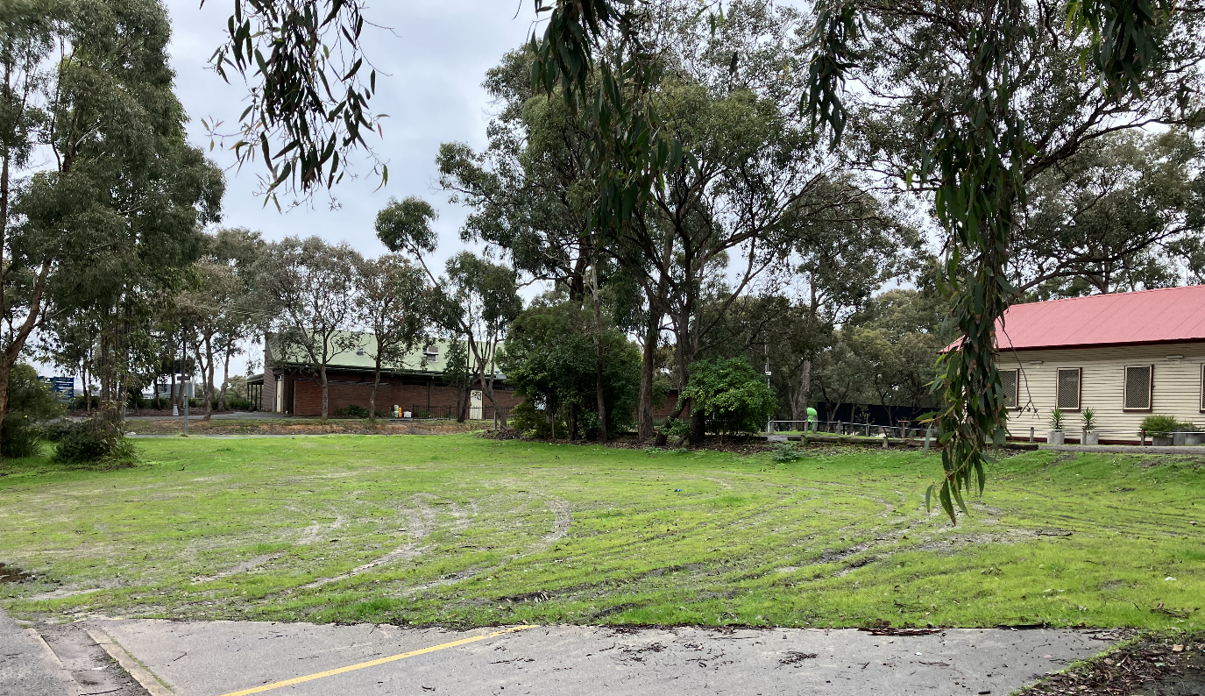

March 2024

Project Background
The site at 109 -115 Yan Yean Road, Plenty was previously home to the Plenty Fire Brigade.

During previous consultation community were asked whether they would like the building retained and repurposed or demolished and the land returned to public open space.

More than 73 per cent of local Plenty residents supported the building being demolished.

Since the construction of the new Plenty Fire Station and the demolition of the old Plenty Fire Brigade this area is now vacant and will be returned to open space.

Concept designs aim to create a space that supports social integration and inclusion, social identity, social participation and health and wellness.

How we engaged
Community consultation was undertaken from 10 July until 30 July 2023. Council’s online engagement platform ‘Participate Nillumbik’ was used to share concept designs. The community were invited to complete a short survey to share their thoughts.

What we heard
Two key questions were asked of the community to understand overall support for the design and what key elements were particularly liked and disliked.

See questions and response summary below:
Question 1:
What do you prefer most in this open space design?
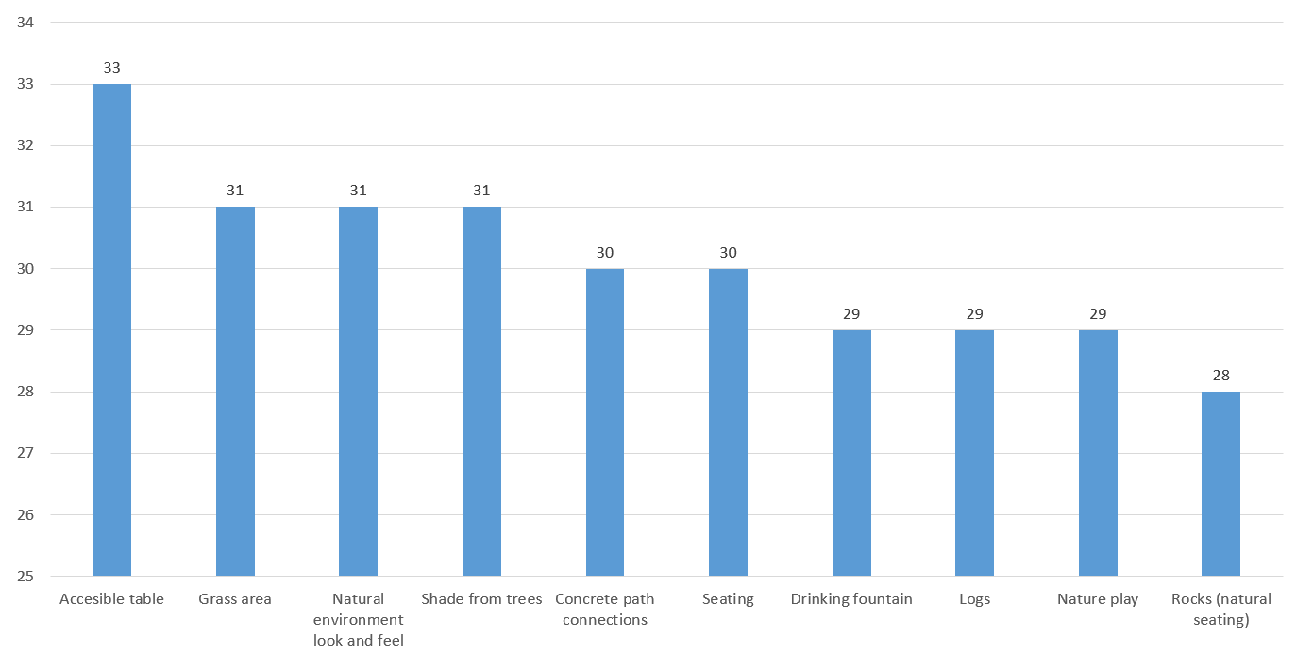
Question 2:
Are there any elements that you would like to see included in stage 1, that are currently planned for stage 2?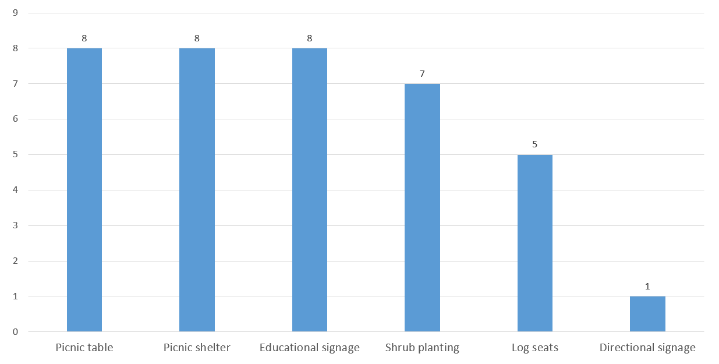
Note: All works will now be delivered in one stage.
Findings
The below summarises key themes and opportunities referenced by the 41 respondents / community:
Importance of creating connection to surrounding landmarks, such as the community hall and church
Importance of recognising heritage and history of site which could include:
- Use of the site by CFA
- Community hall & former Plenty Methodist/Uniting Church
- The Plenty State School
- Old Plenty Store
- First nations / indigenous significance
Support for the inclusion of:
- A community garden
- Solar fairy lights in trees
- Accessible pathways and seating
- Picnic area with seating
- Rotunda / large shelter
Consideration to be given to:
- Relocation of car park
- Species of trees being planted
- Incorporating nature play opportunities

Design
The concept design has been reworked based on feedback received and further community engagement. It includes:

- Formalised entry point
- Pathway connections that extend up to Howell Rd
- Removal of vehicle access (“driveway”) directly from Yan Yean Rd to northern car park
- Reinstate nature strip along Yan Yean Rd
- Improved drainage
- Maintained natural look and feel
- Recognition of historical elements related to the site
The final design can be found on the Participate Nillumbik project page, or by clicking here.

Next steps
Council is in the process of appointing a contractor to undertake works.

All works are anticipated to be completed by end of June 2024.

