Planning and Environment Act 1987

Nillumbik PLANNING SCHEME

AMENDMENT C129

EXPLANATORY REPORT

Who is the planning authority?
This Amendment has been prepared by the Nillumbik Shire Council, which is the planning authority for this Amendment.
The Amendment has been made at the request of Nillumbik Shire Council.

Land affected by the Amendment
The Amendment applies to the land (the affected land) within the orange area in the map below.
The affected land was formerly 323-325 Yan Yean Road, Plenty and now comprises:
- Nos. 18, 20, 21, 22, 23, 24, 25, 25A, 27, 29, 31, 33 and 1/35 Thornbill Drive, Plenty
- Part of the road reserve of Thornbill Drive, Plenty
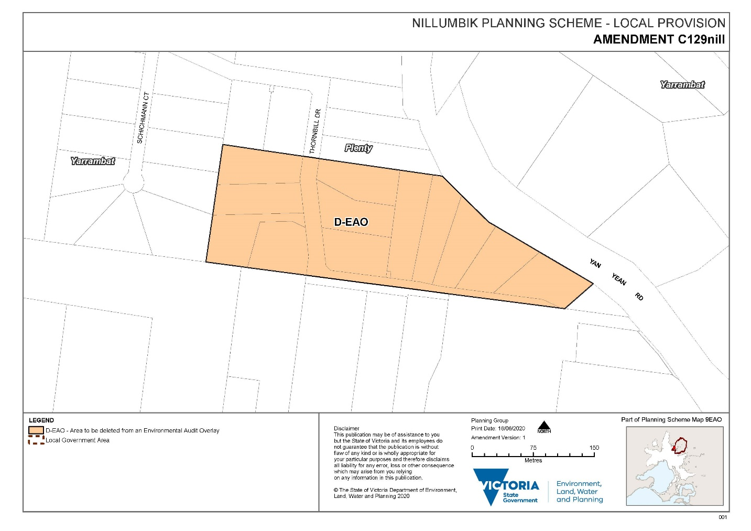
A mapping reference table is attached at Attachment 1 to this Explanatory Report.

What the Amendment does
The Amendment will amend Map No. 9 EAO of the Nillumbik Planning Scheme to show the deletion of the Environmental Audit Overlay (EAO) from the affected land.

Why is the Amendment required?
The affected land for this Amendment was formerly 323-325 Yan Road, Plenty. Environmental assessments and works were completed on land situated at 323-325 Yan Yean Road in Plenty, including an Environmental Audit and remedial and clean up works. These are summarised as follows:
- In 2000, a Statement of Environmental Audit was issued for 323-325 Yan Yean Road, Plenty under section 57AA of the Environment Protection Act 1970 (Environment Act). The Statement, amongst other things, concluded that the affected land is ‘suitable for low density residential use and for agricultural use subject to four (4) conditions’.
The four conditions are:
- Residential use and any use for growing of food for human consumption must be confined to areas outside the area impacted by mullock heaps and/or contaminated fill as defined in the Statement;
- If any earthworks take place within the area impacted by mullock heaps or contaminated fill as defined in the Statement, any soil moved from the area be tested and disposed of in accordance with EPA guidelines;
- No sensitive use take place (residential, child care or growing of crops for human consumption) in the area impacted by the mullock heaps or contaminated fill as defined in the Statement unless the whole of the impacted area is graded and covered with at least 500mm of clean fill; and
- The area impacted by mullock heaps or contaminated fill as defined in the Statement be maintained such that vegetative cover is sufficient to prevent erosion in the soil so that contaminated soil is not moved off the site.
- In December 2016 Council issued a planning permit (80/2016/14P) for 323-325 Yan Yean Road, Plenty for:
Subdivision of the land into 12 lots, removal of vegetation for road construction and rehabilitation of contaminated soil, in accordance with the endorsed plans
Condition 6 of this planning permit required that a report be prepared detailing the satisfactory completion of the clean-up works required by the environmental assessment report.
- In accordance with Condition 6, Connolly Environmental was engaged to conduct soil assessment and remediation prior to subdivision and redevelopment of the affected land for low density residential land use. Examples of the remedial work subsequently conducted include:
- Removal of the mullock heaps in the proposed residential allotments;
- Excavation and validation of chemically impacted soil, above the adopted low density residential criteria in the mullock heap area; and
- Retention of chemically and aesthetically impacted soil beneath the proposed roadway.
- Further, in January 2018, Connolly Environmental prepared a ‘Soil Assessment and Remediation’ report (Connolly Report) to document the outcomes of the assessment and remediation work. In relation to the extent and outcomes of the remedial works, the Connolly Report advises that:
- At the completion of remediation work, soil in the proposed residential allotments was considered to be chemically and aesthetically suitable for low density use, consistent with the existing Statement of Environmental Audit, where:
- The whole of the impacted area was graded and covered with at least 500 mm of clean fill, in accordance with condition 3 of the Statement of Environmental Audit.
- The impacted soil had been appropriately retained (beneath the proposed roadway) to prevent erosion of the soil so that contaminated soil is not moved off the site, in accordance with condition 4 of the Statement of Environmental Audit.
- Chemically and aesthetically impacted soil removed from the mullock heap area, was considered to have been suitably retained beneath the proposed roadway. Soil retained beneath the proposed roadway was below the adopted commercial/industrial criteria, where no direct exposure to residential receptors was reasonably expected.
The General Practice Note ‘Potentially Contaminated Land’ (June 2005) provides Councils with some guidance as to when an EAO should be applied or removed and suggests that an EAO should be removed if:
- It is determined the land is not potentially contaminated land; or
- The site is given a Certificate of Environmental Audit.
The General Practice Note also advises that, in some circumstances, where a Statement of Environmental Audit is issued, it may also be possible to remove the EAO. For example, where there are minimum restrictions or conditions on the use of the site, or the conditions have been complied with. Comment is made in the General Practice Note that the timely removal of an EAO will avoid costly and time-consuming requirements for all parties.
It is Council’s view that the affected land satisfies the circumstances where it is appropriate to remove the EAO, noting:
- The location and extent of existing contamination is known as identified by the 2000 environmental assessment report and the Connolly report.
- A Statement of Environmental Audit has been issued which finds the affected land is suitable for low-density residential and agricultural use subject to conditions (detailed above).
- Remedial works have been conducted which implement the conditions of the State of Environmental Audit to allow low-density residential living.
- Council considers the remaining restrictions and conditions of the Statement of Environmental Audit are suitably minor in terms of the effort required for compliance.
- A Section 173 Agreement was applied in 2019 to all land formerly known as 323-325 Yan Yean Road which requires compliance with the conditions of the Statement of Environmental Audit by current and future owners. (This Section 173 Agreement was finalised and was registered on title by Land Use Victoria on 20th September 2019 in dealing number AS541744C).
Hence, this Amendment proposes to remove the EAO from the affected land.

The Amendment will give effect to an outcome where the issues have been reasonably considered and the views of affected parties are known.

How does the Amendment implement the objectives of planning in Victoria?
The Amendment implements the following objectives as set out in Section 4 of the Planning and Environment Act 1987:

- Section 4(1) (a) To provide for the fair, orderly, economic and sustainable use and development of land.
• Section 4(1) (b) To provide for the protection of natural and man-made resources and the maintenance of ecological processes and genetic diversity.
• Section 4(1) (c) To secure a pleasant, efficient and safe working, living and recreational environment for all Victorians and visitors to Victoria.
• Section 4(1) (g) To balance the present and future interests of all Victorians.

How does the Amendment address any environmental, social and economic effects?

The Environmental Audit prepared for the affected land, provides an independent review of the environmental condition of the land and allows for an opinion regarding its suitability for intended or potential uses. The resulting subdivision permit for the affected land, and Section 173 Agreement on title that requires compliance with the conditions of the Statement of Environmental Audit, removes potential for adverse environmental effects, whilst enabling development of the affected land.
The continued application of the EAO on the affected land leaves an unfair and unnecessary legacy on current and future property owners who have bought into the subdivision, whereas the Section 173 Agreement in place on title provides certainty in regard to contamination mitigation and ongoing containment and gives the Responsible Authority the ability to satisfy itself of ongoing contamination mitigation in assessing any future applications for dwellings or other sensitive uses at the affected land.

Does the Amendment address relevant bushfire risk?
The proposed Amendment will not result in any increased bushfire risk.

Does the Amendment comply with the requirements of any Minister’s Direction applicable to the Amendment?
This Amendment supports Direction 2.4 in facilitating decision-making processes for housing in the right locations particularly with regard to contamination, as set out in Plan Melbourne 2017 – 2050.

The Amendment will improve the effectiveness and efficiency of the Nillumbik Planning
Scheme and will remove an unnecessary obstacle to the future development of the affected land.

The Amendment is consistent with the Ministerial Direction on the Form and Content of Planning Schemes under section 7(5) of the Act.

The Amendment complies with Minister’s Direction No 11, ‘Strategic Assessment of Amendments’. All requirements to be met under the direction have been considered and met in the preparation of the Amendment.

The Amendment is consistent with the current Ministerial Direction 1 for “Potentially Contaminated land” and the General Practice Note for Potentially Contaminated Land where the affected land has been assessed and a Statement of Environmental Audit has been issued. Consistent with the Practice Note, Council has satisfied itself of continued compliance with the conditions of the Statement of Environmental Audit through the use of a Section 173 Agreement applied on title for the resulting subdivision permit issued for the affected land.

It is noted this approach has also been supported through proposed updates to the Environment Protection Act 2017 (as amended by the Environment Protection Amendment Act 2018) (EP Act) that will take effect from 1 July 2021. Proposed updates to Victoria's land-use planning system in line with the EP Act reforms are also intended to commence at that time.

The Draft Ministers Direction 1 and Planning Practice Note (PPN) 30 Potentially Contaminated Land, proposed as part of the amended Victorian Planning Provisions pursuant to changes to the EP Act, identify no requirement for the issue of a Certificate of Environmental Audit to facilitate removal of an EAO. The assessment framework identified within the PPN instead puts onus on the preparation of an Environmental Audit (and any resulting conditions of remediation which can be included in a planning permit through a Section 173 Agreement) with no requirement for the subsequent Certificate.

How does the Amendment support or implement the State Planning Policy Framework and any adopted State policy

The Amendment is consistent with State policy 13.04-1S Use of contaminated and potentially contaminated land where the objective of this clause is to ensure that potentially contaminated land is suitable for its intended future use and development, and that contaminated land is used safely.

The EAO is currently applied to all the land affected by this Amendment. However, a Statement of Environmental Audit has been issued for the land and expert technical opinion identifies that effective mitigation works have been undertaken in accordance with the conditions of the Statement. Further, restrictions on title, implemented by a Section 173 Agreement, allow Council to effectively require ongoing compliance with the conditions of the Statement.

How does the Amendment support or implement the Local Planning Policy Framework, and specifically the Municipal Strategic Statement?

The Amendment supports the implementation of the LPPF. Specifically, the proposed Amendment advances the following local planning policies.

Clause 21.05-3 Environment, Conservation & Landscapes includes Objective 2 which seeks to ensure land use and development is assessed in the context of its potential effect on the wider catchment and encourages sustainable land management by:
- Encouraging coordinated environmental management of public and private land;
- Protecting the natural systems including land, air and water from pollution and detrimental activities in accordance with relevant State legislation including State Environment Protection Policies, best practice environmental management guidelines and approved catchment strategies; and
- Ensuring land use and development is consistent with identified land capability and environmental constraints and is managed to have minimum adverse impact on neighbouring properties and the catchment.

Does the Amendment make proper use of the Victoria Planning Provisions?
The Amendment seeks to ensure that the Victorian Planning Provisions are correctly applied through the correct application of overlays and reflects the current and future intended use of the land. Consistent with the requirements of the General Practice Note for Potentially Contaminated Land (June 2005), the Responsible Authority is satisfied that the conditions of the Statement of Environmental Audit have been effectively upheld and will continue to apply through a Section 173 Agreement entered into as part of a planning permit for the resulting subdivision of the affected land. This imposes a legal requirement on the existing and future owners of the land to fulfil the conditions of the Statement of Environmental Audit.

How does the Amendment address the views of any relevant agency?

The views of relevant agencies will be sought during the public exhibition process.

Does the Amendment address relevant requirements of the Transport Integration Act 2010?

The Transport Integration Act 2010 requires that a planning authority have regard to transport system objectives and decision-making principles where a planning scheme amendment is likely to have a ‘significant impact on the transport system’. There are no statements of policy principles relevant to the Amendment.

What impact will the new planning provisions have on the resource and administrative costs of the responsible authority?

The Amendment will have limited impact on the Responsible Authority’s resource and administrative costs as it will only clarify future planning requirements.

Where you may inspect this Amendment
The Amendment can be inspected free of charge at the Nillumbik Shire Council’s public engagement website at https://participate.nillumbik.vic.gov.au/
Council’s offices will be closed during the Covid-19 State of Emergency. If you require a hard copy, or if you have difficulty accessing the documents please contact the Strategic Planning team via strategic.planning@nillumbik.vic.gov.au
And/or
The Amendment can also be inspected free of charge at the Department of Environment, Land, Water and Planning website at:
https://www.planning.vic.gov.au/schemes-and-amendments/amending-a-planning-scheme/planning-documents-on-exhibition

Submissions

Any person who may be affected by the Amendment may make a submission to the planning authority. Submissions about the Amendment must be received by Monday 16 November 2020.
A submission must be sent to:
Rosa Zouzoulas
Executive Manager Planning and Community Safety
Nillumbik Shire Council
Civic Drive (PO Box 476)
Greensborough 3088
Alternatively, a submission can be sent electronically via email to: strategic.planning@nillumbik.vic.gov.au

Panel hearing dates
In accordance with clause 4(2) of Ministerial Direction No.15 the following panel hearing dates have been set for this Amendment:
- directions hearing: To commence in week of 22 March 2021.
- panel hearing: To commence in the week of 19 April 2021.

ATTACHMENT 1 - Mapping reference table
Location | Land /Area Affected | Mapping Reference
Plenty | - Nos. 18, 20, 21, 22, 23, 24, 25, 25A, 27, 29, 31, 33 and 1/35 Thornbill Drive, Plenty  - Part of the road reserve of Thornbill Drive, Plenty | Nillumbik C129nill 001d-eaoMap09 Exhibition

