Planning and Environment Act 1987

Nillumbik PLANNING SCHEME

AMENDMENT C126

EXPLANATORY REPORT

Who is the planning authority?
This amendment has been prepared by the Nillumbik Shire Council, which is the planning authority for this amendment.
The Amendment has been made at the request of Nillumbik Shire Council.

Land affected by the Amendment
The Amendment applies to the following land:
- Eastern end of John Street, Eltham
- Eastern end of Bridge Street, Eltham
A mapping reference table is attached at Attachment 1 to this Explanatory Report.

What the amendment does
The Amendment proposes to:
- Partially rezone the eastern end of John Street, Eltham from Neighbourhood Residential Zone Schedule 1 to Public Park and Recreation Zone.
- Partially rezone the eastern end of Bridge Street, Eltham from Neighbourhood Residential Zone Schedule 1 to Public Park and Recreation Zone.

Strategic assessment of the Amendment

Why is the Amendment required?
The amendment is required to implement the findings of a review of this Council managed land that is currently serving a public open space function, but not appropriately zoned. The review found that these sections of road reserve were no longer required for the purpose of vehicular use, Council is in the process to discontinue these two road reserves pursuant to the statutory process under the Local Government Act 1989 and retain the resultant land for public park and recreation, including pedestrian access.

Please see Figure 1 for mapping of access points of properties adjoining the land proposed to be rezoned.
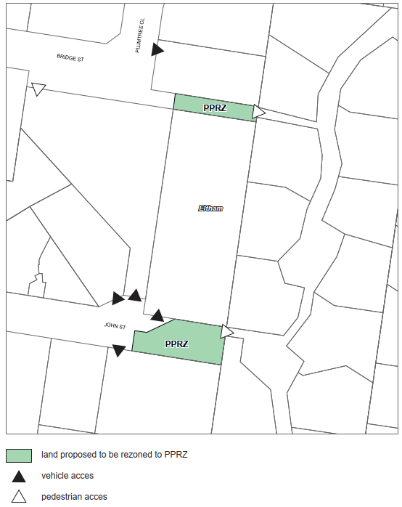
Figure 1: Access of Adjoining Properties

Figure 2 has also been included below to show that the subject sites are existing pedestrian linkages to the Harlington Avenue units and surrounds. These pedestrian linkages are used by residents including to walk the neighbourhood and their dogs. The adjoining Harlington Avenue is a pedestrianised environment and not a thoroughfare. These existing linkages continue this pedestrian access.

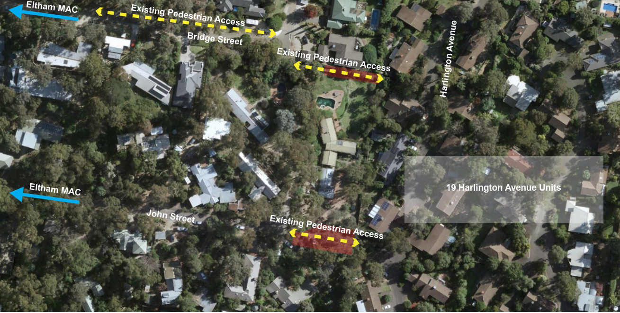
Figure 2: Access of Adjoining Properties

These pocket parks optimise accessibility between John and Bridge Street to Harlington Avenue in the west but also provide direct linear pedestrian access along Bridge and John Street to larger open spaces such as the Macmahon Ball Paddock and the Alistair Knox Park and amenities located in the Eltham Major Activity Centre (MAC) in the east. Formalising these pocket parks will enhance the permeable neighourhood street network. The Harlington Avenue development has limited permeability; with access only to heavily trafficked Pitt Street. The formalisation of these existing pedestrian linkages not only optimises these permeable spaces (makes them more attractive for walking), but again formalises and improves pedestrian linkages to the Eltham Town Centre providing a viable, safe and less busy access to the town centre via John and Bridge Street.

The Amendment is supported by the Nillumbik Council Plan 2017-2021 reflected in the following objectives:
- 2.1 Provide a range of infrastructure that encourages people of all ages to participate in a variety of active and passive opportunities.
- 2.2 Create active places and spaces that have good connectivity, provide needed infrastructure and promote social interaction.

The Amendment is required to apply the Public Park and Recreation Zone (PPRZ) to Council managed land to ensure council’s open space assets are correctly zoned in applying orderly planning to reflect their open space purpose. The primary purpose of the Zone is to recognise areas for public recreation and open space and to protect and conserve the natural environment.

Pursuant to 5.1 Applying a zone from A Practitioner’s Guide to the Victorian Planning Schemes, the Amendment also allows Council as the public land manager to undertake works and ongoing maintenance without the need for a planning permit in provision of and upkeep of these open spaces. 5.1.1 Public land states that a public land manager should be able to use and develop public land for any purpose under the relevant land management legislation without the need for a permit. This is achieved by allowing many uses to be Section 1 within a public land zone.

This amendment will apply the appropriate zone to ensure the land use is consistently and appropriately recognised for meeting the open space requirements of the local community. This is particularly relevant in urban areas including the Eltham MAC and surrounds, where increasing urban density is impacting the provision of private open space. These ‘pocket parks’ play an important role for communities by providing:
- Localised opportunity, both informal and formal for recreational activities.
- Social cohesion and community connectedness.
- Environmental benefits.

A new Eltham MAC Structure Plan was adopted by Council on 28 July 2020. The study area was defined by Council when the original structure plan was prepared in 2004. It has remained largely the same due to the continued sufficient capacity for development and change. Minor changes made to the boundaries include adding Andrew Park (27 Youth Road) and the site of St Vincent’s Care Services (43 Diamond Street) as additional precincts and important sporting and community facilities in the Activity Centre. The subject site is not within the Eltham MAC but it is in close proximity to it (see Figure 3). The subject sites are within 900m at its furthest point of the Structure Plan boundary. Under 4.4 Built Form Character of the Eltham Structure Plan, one of the objectives include ‘to provide continuously accessible pathways within the Activity Centre and connecting to surrounding suburbs.’ The subject sites provide amenity in the area and as well as connectivity to the Eltham MAC.

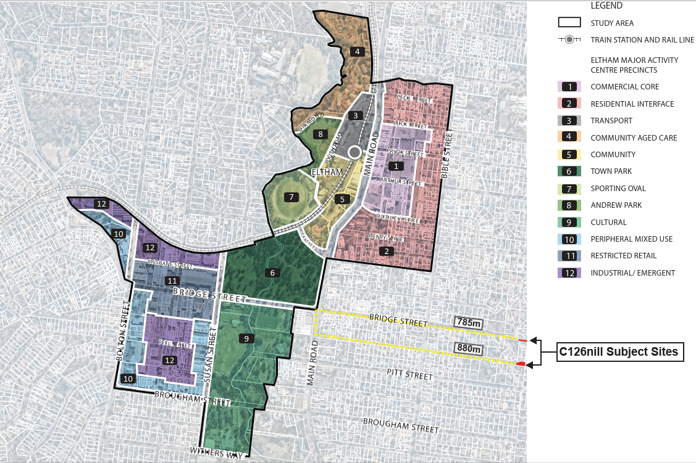
Figure 3: Adopted Eltham Structure Plan – Showing Location of C126nill

Council’s Open Space Strategy 2005 defines Council’s vision and strategic direction for the development and management of open space. In this Strategy, Eltham was identified as one of the areas within the Urban Open Space System. The Strategy aims that in urban areas, the open space system needs to provide a broad range of recreational facilities and open space areas. One of the objectives to implement Council’s Open Space Vision of the urban space system includes providing accessible, functional and diverse open space within walking distance from all homes. The subject site will encourage this objective by providing a pocket park and will provide access to other reserves within the Urban Open Space System.

The importance of small scale green open spaces and the localized opportunity for lifetime play is recognised in the Nillumbik Lifetime Play Strategy, 2018. The Nillumbik Health and Wellbeing Plan 2017-2021 includes the key strategy ‘Encourage Active Living’, which identifies the objective to design, develop and promote the development of built infrastructure and the natural environments that support active transport, improved walkability and active recreation.

The proposed pocket parks on Bridge and John Street will form a larger network of pocket parks and larger reserves within the residential areas of Eltham. Some of the larger green open spaces include the Alistair Knox Park to the west and Arthur Bird Reserve to the east. Please see Figures 4 and 5 for maps of surrounding pocket parks and their distances from the subject sites.

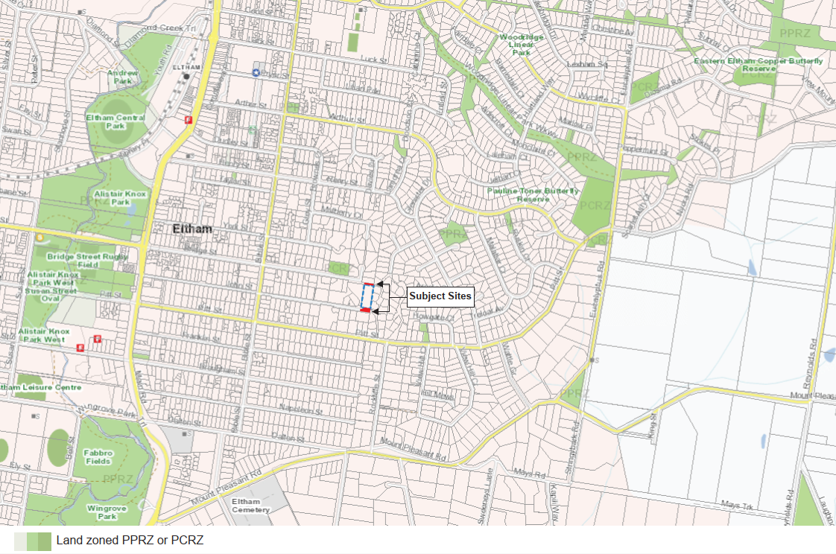
Figure 4: Mapping of Pocket Parks and Reserves

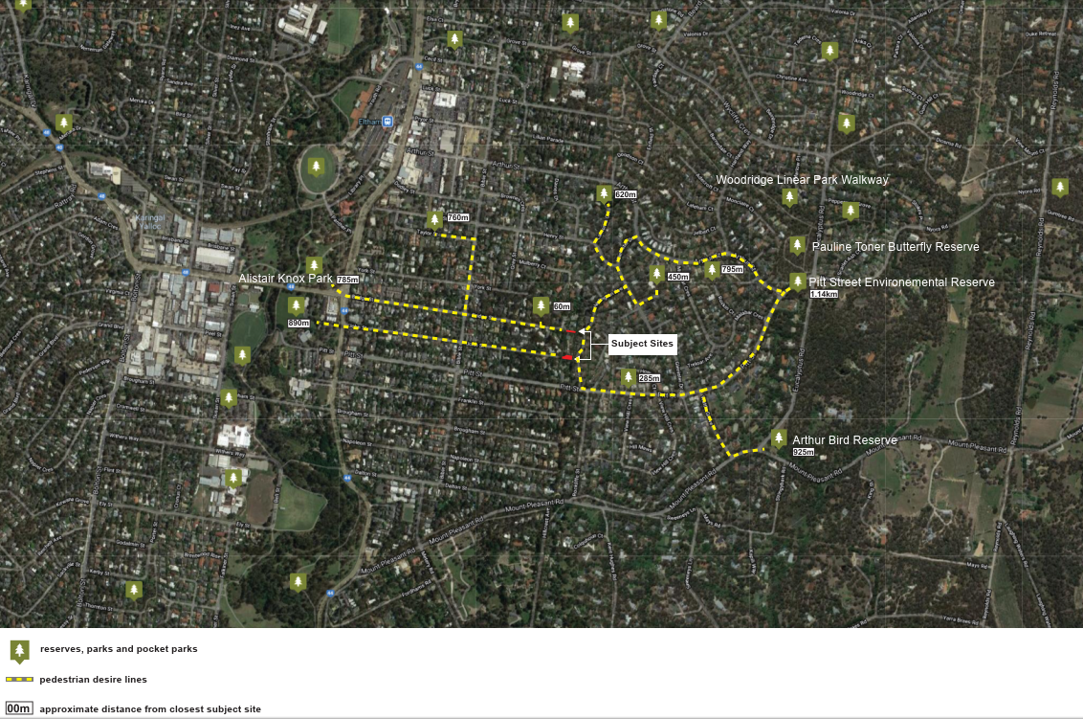
Figure 5: Mapping of C126nill Surrounding Reserves and Pedestrian Desire Lines

How does the Amendment implement the objectives of planning in Victoria?
The Amendment implements the following objectives as set out in Section 4 of the Planning and Environment Act 1987:

- Section 4(1) (a) To provide for the fair, orderly, economic and sustainable use and development of land.
• Section 4(1) (b) To provide for the protection of natural and man-made resources and the maintenance of ecological processes and genetic diversity.
• Section 4(1) (c) To secure a pleasant, efficient and safe working, living and recreational environment for all Victorians and visitors to Victoria.
• Section 4(1) (g) To balance the present and future interests of all Victorians.

How does the Amendment address any environmental, social and economic effects?
- The amendment is expected to have positive environmental effects and economic and social benefits as it will confirm the intended status and management of land as public open space.
- The social interactions and community building that public open spaces bring enhances community connectivity and community capital.
- Retention of the open space assists in maintaining the attractiveness and amenity of the public realm.
- Retention of the open space will continue to provide habitat for flora and fauna within the predominantly urban environment.
- Pockets of planted open space help connect larger patches of bushland, and allow freedom of movement for wildlife.

Does the Amendment address relevant bushfire risk?
The proposed amendment will not result in any increased bushfire risk.

Does the Amendment comply with the requirements of any Minister’s Direction applicable to the amendment?
The Amendment complies with the requirements of the Ministerial Direction on the Form and Content of Planning Schemes under section 7(5) of the Planning and Environment Act 1987. The Amendment complies with the Minister’s Directions under Section 11 – Strategic Assessment of Amendments.
This Amendment supports the following directions and policy set out in Plan Melbourne 2017 - 2050, the State’s current metropolitan planning strategy:

- Direction 5.4 Deliver local parks and green neighbourhoods in collaboration with communities.

- Direction 6.4 Make Melbourne cooler and greener.

- Direction 6.5 Protect and restore natural habitats.

How does the Amendment support or implement the State Planning Policy Framework and any adopted State policy
This Amendment supports the objective of Clause 19.02 Open Space to establish, manage and improve a diverse and integrated network of public open space that meets the needs of the community. Specifically, the amendment supports the following strategy set out in Clause 19.02 6S:

- Ensure that urban open space provides for nature conservation, recreation and play, formal and informal sport, social interaction, opportunities to connect with nature and peace and solitude.

The Victorian Health and Wellbeing Plan 2019-2023, outlines the government’s key priorities to improve the health and wellbeing of Victorians. Priorities supported by the Amendment include increasing active living by increasing easy access to parks, open spaces and public spaces with opportunities for physical activity where appropriate.
Plan Melbourne 2017-2050 highlights the importance of 20-minute neighbourhoods. The 20-minute neighbourhood concept aims to improve livability by giving people the ability to meet most of their daily needs within a 20-minutewalk from home. The subject sites are within 12-15 minute walks from the Eltham MAC. The formalisation of these pocket parks will advance the objectives of Plan Melbourne 2017-2050 and continue providing access to the residents’ daily needs such as recreation and as well as services provided with the Eltham MAC.

How does the Amendment support or implement the Local Planning Policy Framework, and specifically the Municipal Strategic Statement?

The Amendment supports the implementation of the LPPF. Specifically, the proposed Amendment conforms to the following local planning policies.
Clause 21.05 Infrastructure includes Objective 4 that seeks to provide equitable local recreational facilities and public open spaces to meet local community needs including to:
- Encourage, particularly through structure plans and strategies, the formation of open spaces and opportunities to link areas of public open space;
- View open space as an environmental resource and as a means of protecting significant habitat;
- Rezoning the proposed properties to a Public Park and Recreation Zone will ensure that the open space needs of a growing population are met.

Does the Amendment make proper use of the Victoria Planning Provisions?
The amendment seeks to ensure that the Victorian Planning Provisions are correctly applied through the correct application of zones and reflects the current and future intended use of the land.

How does the Amendment address the views of any relevant agency?

The views of relevant agencies will be sought during the public exhibition process.

Does the Amendment address relevant requirements of the Transport Integration Act 2010?

The Transport Integration Act 2010 requires that a planning authority have regard to transport system objectives and decision-making principles where a planning scheme amendment is likely to have a ‘significant impact on the transport system’. The effect of this amendment is consistent with the transport system objectives outlined in the Act. A planning authority must also have regard to any statement of policy principles which have been issued under section 22 of the Transport Integration Act. There are no statements of policy principles relevant to the amendment.

Resource and administrative costs

What impact will the new planning provisions have on the resource and administrative costs of the responsible authority?

The amendment reduces the number of unnecessary planning permit applications and the workload of planning staff.

Where you may inspect this Amendment
The amendment can be inspected free of charge at the Nillumbik Shire Council’s website at www.participate.nillumbik.vic.gov.au/
And/or
The Amendment is available for public inspection, free of charge, during office hours at the following places:
Nillumbik Shire Council Offices
Civic Drive
Greensborough 3088
The Amendment can also be inspected free of charge at the Department of Environment, Land, Water and Planning website at www.planning.vic.gov.au/schemes-and-amendments/amending-a-planning-scheme/planning-documents-on-exhibition

Submissions

Any person who may be affected by the amendment may make a submission to the planning authority. Submissions about the amendment must be received by 18 February 2021.
A submission must be sent to: Nillumbik Shire Council
Civic Drive (PO Box 476)
Greensborough 3088

Council’s offices will be closed during the Covid-19 State of Emergency. If you require a hard copy, or if you have difficulty accessing the documents please contact the Strategic Planning team via strategic.planning@nillumbik.vic.gov.au.

Panel hearing dates
In accordance with clause 4(2) of Ministerial Direction No.15 the following panel hearing dates have been set for this amendment:
- directions hearing: To commence in week of 26 April 2021.
- panel hearing: To commence in the week of 24 May 2021.

ATTACHMENT 1 - Mapping reference table
Location | Land /Area Affected | Mapping Reference
Eltham | Eastern end of John Street and Bridge Street, Eltham | Nillumbik C126nill 001znMap13 Exhibition

