Planning and Environment Act 1987

Nillumbik shire council PLANNING SCHEME

AMENDMENT C133

EXPLANATORY REPORT

Who is the planning authority?
This amendment has been prepared by the Nillumbik Shire Council, which is the planning authority for this amendment.
The Amendment has been made at the request of Nillumbik Shire Council.

Land affected by the amendment
The amendment applies to 13 Park West Road, Eltham.
A mapping reference table is attached at Attachment 1 to this Explanatory Report.

What the amendment does
The amendment amends a Heritage Overlay (HO147) at 13 Park Road West, Eltham in order to protect a structure known as the Alan Marshall Bungalow and surrounds.
The amendment amends Planning Scheme Map No 13 to show the correct location of heritage overlay (HO147) which will cover the structure (including internal controls), a 5m curtilage and a pathway to Park West Road, Eltham.
The amendment inserts a Statement of Significance at Clause 72.04 Incorporated Documents and a Citation at Clause 72.08 Background Documents.
Figure 1 shows the incorrect application of HO147 and the current application of HO268 which applies interim controls to protect the structure. Figure 2 shows the application of the proposed HO147 which will provide the protections as described above.
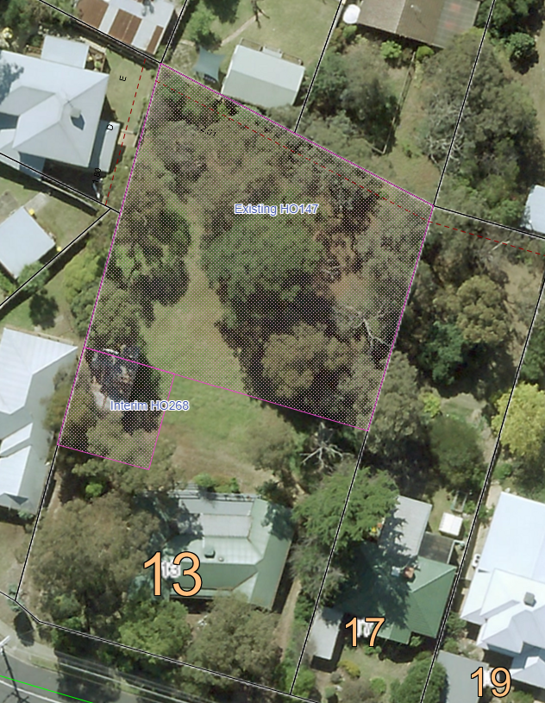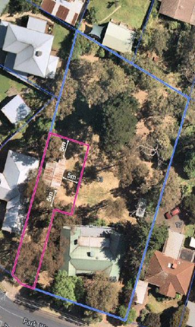
Figure 1. Figure 2.

Strategic assessment of the amendment

Why is the amendment required?
The amendment is required to provide permanent protection to the structure known as the Alan Marshall bungalow and surrounds located at 13 Park West Road, Eltham.
The Alan Marshall bungalow was first identified as historically significant in the Shire of Eltham Heritage Study 1992 and a heritage overlay was applied through Amendment C3 in 2001. The bungalow is historically significant because it was the home of the distinguished Australian author, Alan Marshall from about 1955 to 1972, during which time he wrote the Eltham Shire History Pioneers and Painters. The bungalow is also significant because it’s very basic nature reflects Marshall's lifestyle at the time.
A demolition application was received in 2004 and Council sought further confirmation of the heritage value of the structure and surrounds. The structure and surrounds was assessed as having local social and historical significance and neither demolition nor relocation was supported.
An existing heritage overlay (HO147) applies, however, this was incorrectly mapped to cover the rear of the site and only a small portion (to the north) of the bungalow itself.
An updated citation recommends revising the curtilage from a radius of 15m to a 5m curtilage on the north, east and south of the bungalow and to the property boundary on the west along with a pathway to Park West Road. Internal controls will be applied.
This amendment seeks to correct the mapping error by updating the heritage overlay (HO147) as per planning map Nill C133nill 002hoMap13 Exhibition.

How does the amendment implement the objectives of planning in Victoria?
The amendment implements the objectives of planning in Victoria as set out in Section 4 (1) and 12 (1) of the Planning and Environment Act 1987 (the Act). The following objectives in Section 4 (1) are particularly relevant to the amendment:
- 4(1d) - to conserve and enhance those buildings, areas or other places which are of scientific, aesthetic, architectural or historical interest, or otherwise of special cultural value
- 4(1g) - to balance the present and future interests of all Victorians
The following objectives in Section 12 (1) are relevant to the amendment:
- 12(1) A planning authority must—
(a) implement the objectives of planning in Victoria

How does the amendment address any environmental, social and economic effects?
The amendment will provide assured protection for a significant heritage site within the Shire of Nillumbik.

Does the amendment address relevant bushfire risk?
The Amendment will not increase the risk of life, property, community infrastructure and the natural environment from bushfire.

Does the amendment comply with the requirements of any Minister’s Direction applicable to the amendment?
The amendment is consistent with the Ministerial Direction 1 on the Form and Content of Planning Schemes under section 7(5) of the Act and Ministerial Direction 11: Strategic Assessment Guidelines under Section 12(2) of the Act.
The amendment has been prepared with regard to Ministerial Direction 9: Metropolitan Planning Strategy, which refers to Plan Melbourne 2017-2050. The amendment is particularly consistent with the following direction in Plan Melbourne 2017-2050, as outlined below:
Direction 4.4 Respect Melbourne’s heritage as we build for the future
- Policy 4.4.1 Recognise the value of heritage when managing growth and change
The amendment recognises the need for require careful management of the ongoing processes of change to the urban environment and that decisions must be based on an appreciation of Melbourne’s past as well as an understanding of its future needs.

How does the amendment support or implement the Planning Policy Framework and any adopted State policy?
The amendment supports or implements the following clauses of the Planning Policy Framework:
Clause 15 Built Environment and Heritage
- Planning should ensure all land use and development appropriately responds to its surrounding landscape and character, valued built for form and cultural context.
Clause 15.03-1S Heritage conservation
- Objective: To ensure the conservation of places of heritage significance.
- Strategies:
  - Retain those elements that contribute to the importance of the heritage place.
  - Provide for the protection of natural heritage sites and man-made resources.
  - Support adaptive reuse of heritage buildings where their use has become redundant

How does the amendment support or implement the Local Planning Policy Framework, and specifically the Municipal Strategic Statement?
The amendment supports the Local Planning Policy Framework (LPPF), including the Municipal Strategic Statement (MSS) of the Nillumbik Planning Scheme:
- 21.05-3 - To protect places of natural and cultural heritage.
  - Strategy - Protect heritage sites, buildings and trees identified in heritage studies and undertake ongoing review of places for their heritage significance

How does the amendment support or implement the Municipal Planning Strategy?
Not applicable.

Does the amendment make proper use of the Victoria Planning Provisions?
The amendment seeks to ensure that the Victorian Planning Provisions are correctly applied through the correct application of Heritage Overlay and to reflect the current and future intended use of the land.
The Heritage Overlay is the most appropriate mechanism for recognising and protecting the cultural heritage significance of the identified place.
The Amendment is consistent with Planning Practice Note 01 with regard to the amendment mapping. The mapping identifies the main structure of the bungalow and a curtilage of 5m that has been extended around the structure along with a pathway to Park West Road.
The curtilage aligns to one property boundary and the remaining 5m curtilage (on the North, East and South) provides for the setting/surrounds of the bungalow. In addition, a pathway, which is the width of the bungalow including roof overhang, has been added to the curtilage. This pathway will retain the setting and context of the bungalow whilst maintaining a visual link to the street. The internal controls will provide protection for the fabric of the structure.
The mapping has been set to reduce the likelihood for potential dispute in terms of the land affected by any future Overlay knowing that a development application has already been received.
The Amendment also complies with Planning Practice Note 01 with regard to assessment against the set criteria with Criterion H: Special association with the life or works of a person, or group of persons, of importance in our history (associative significance) being appropriate.
The Amendment is consistent with Planning Practice Note 01 with regard to applying the Heritage Overlay, in that the title of the statement of significance is specified in the schedule to the overlay. The schedule to the overlay is also annotated with regard to the extent of the curtilage to ensure the retention of the structure and fabric of the bungalow, its surroundings and pathway to Park West Road are protected by regulating the proposed development.

How does the amendment address the views of any relevant agency?
The views of relevant agencies will be sought during the public exhibition process.

Does the amendment address relevant requirements of the Transport Integration Act 2010?
The Transport Integration Act 2010 requires that a planning authority have regard to transport system objectives and decision-making principles where a planning scheme amendment is likely to have a ‘significant impact on the transport system’. There are no statements of policy principles relevant to the amendment.

What impact will the new planning provisions have on the resource and administrative costs of the responsible authority?
The amendment will have minimal impact on the resource and administrative costs of the responsible authority.

Where you may inspect this amendment
The amendment can be inspected free of charge at the Nillumbik Shire Council’s website at https://participate.nillumbik.vic.gov.au/
And/or
The Amendment is available for public inspection, free of charge, during office hours at the following places:
Nillumbik Shire Council Offices
Civic Drive
Greensborough 3088

The Amendment can also be inspected free of charge at the Department of Environment, Land, Water and Planning website at: www.planning.vic.gov.au/public-inspection.

Submissions
Any person who may be affected by the amendment may make a submission to the planning authority about the amendment. Submissions must be made in writing giving the submitter’s name and contact address, clearly stating the grounds on which the amendment is supported or opposed and indicating what changes (if any) the submitter wishes to make.
Name and contact details of submitters are required for council to consider submissions and to notify such persons of the opportunity to attend council meetings and any public hearing held to consider submissions. The closing date for submissions is 12th July 2021. A submission must be sent to:
Rosa Zouzoulas
Executive Manager Planning and Community Safety
Nillumbik Shire Council
Civic Drive (PO Box 476)
Greensborough VIC 3088
Alternatively, a submission can be sent electronically via email to: strategic.planning@nillumbik.vic.gov.au
A copy of every submission, redacted to remove each submitter’s personal information, will be available at Council’s Participate Nillumbik website (https://participate.nillumbik.vic.gov.au/) for any person to inspect free of charge for two months after the amendment comes into operation or lapses.
The full content of a personal submission including any name/s is a public record and may be made available for public inspection and included in Council business papers. Contact information will be redacted. Names will not be redacted unless anonymity is expressly requested and confidentiality granted to a submission.
The full content of a submission made on behalf of an organisation in relation the amendment, including the name of the organisation is a public record and may be made available for public inspection and included in Council business papers.
Not providing the mandatory information will mean that your submission cannot be accepted.
You have the right to access and correct your personal information. Enquiries for access should be made to the Privacy Officer 9433 3271, privacy@nillumbik.vic.gov.au or PO Box 476, Greensborough Vic 3088.

Panel hearing dates
In accordance with clause 4(2) of Ministerial Direction No.15 the following panel hearing dates have been set for this amendment:
• directions hearing: 24th September 2021.
• panel hearing: 25th October 2021.

ATTACHMENT 1 - Mapping reference table

Location | Land /Area Affected | Mapping Reference
Eltham | 13 Park West Road | Nillumbik C133nill 001d-hoMap13 Exhibition.
Eltham | 13 Park West Road | Nillumbik C133nill 002hoMap13 Exhibition.

